The Peace building Initiative (TPI) East: Youth and Women as pillars of Peace in Eastern Terai

First Quarterly Report

Submitted by
Samagra Jana Utthan Kendra (Samagra), Siraha Lahan

Submitted to
Search for Common Ground

Reporting period:
1st May 2012 to 31st July

Date of submission
7th August

Contact information
Rajendra Subba Project Manager Mobile: 9841380550 Email: rajendrasubba@gmail.com

Executive Summary
With support from Search for Common Ground Nepal, Samagra Jana Utthan Kendra (SAMAGRA) has been implementing the project entitled "The Peace building Initiative (TPI) East" in four districts of eastern terai namely Saptari, Siraha, Dhanusha and Mahottari since 1st May 2012 with aim to enhance the participation of women and youth in peace building and community led decision making.
This project has been designed to strengthen the role of youth and women in peace building. The specific objectives of the project include:
- To enhance the participation of women and youth in peace building and community led decision making,
- To increase the receptiness of local government institutions particularly VDC to include women and youth in decision making process,
- To build the capacity of women leaders at the district and regional level in collaborative leadership and dialogue and
- To foster constructive engagement of youth and women and local decision makers in the peace process at local level
This first quarterly report covers all the activities implemented from 1st May 2012 to 31st July 2012 and presents significant progress made during this period. It also consists of the activities and outputs of the next quarter. During this first quarter, the following activities have been carried out:
- Conducted VDCs survey in four districts for identifying youth club & women group and 20 VDCs, 15 women groups and 19 youth clubs selected.
- Formed District level Project Advisory Committee in Siraha and Saptari, and VDC level Project Advisory Committee in 15 VDCs
- Conducted a four-day Training of Trainers (ToT) for 21 male youths and 8 female youth leaders from four districts namely Siraha, Saptari, Dhanusha and Mahottari.
- Conducted a four-day Training of Trainers (ToT) for 23 women leaders from four districts namely Siraha, Saptari, Dhanusha and Mahottari.
- Conducted community orientation on local resource and access of youth and women to it, good governance, role of youth and women in local development and peace building etc in 16 communities.
From the administered activities during this first quarter, the result is encouraging. Women and youth have been aware of government policy on youth and women and local resource. They have started taking interests on participation and local resource. The stakeholders are positive to them. They have promised to hear their voice if youth and women come as group/ club. There is women participation in satisfactory number in the program. They come in scarf on head and normally speak less and in more cases do not speak but listen. Similarly women and youth leaders have been given leadership training. In many VDCs, those ToT participants coordinated and organized orientation programs after ToT. Project Advisory Mechanism in district and VDCs have been formed and VDC level mechanism is now functioning. They are holding meeting and discussing on project related issues in the VDCs.
Despite these encouraging results there are challenges too. VDC secretary stations in district headquarters so getting them participate in VDC level activities is very much challenging. In some VDC, there is not good relation between local youths and political parties and secretary. VDC secretaries do not want to go to VDC due to conflict. Youth and women participation in local level decision making mechanism is not satisfactory. There is nominal participation of women. Youths are mostly ignored and not participated in decision making process. Women and youths are not yet taken as change maker agent. Youths are more concerned with employment. They are not stable. They leave village for employment. This creates discontinuity and instability in youth groups or club.
Finally, community dialogue for conflict transformation, community awareness for reducing stereotyping and biasness towards women and youths, and capacity building with link to income generation is must.

Distritct context
There exists negative peace in the terai since the dissolution of Constituent Assembly. Conflict and violence particularly physical one has not taken place like before the dissolution of Constituent Assembly. Violence, however against women and human rights violation has not ceased yet. Recently one boy was fed human stool by his own relative in accusation of witchery. Human security condition is also not so satisfactory. Kidnapping is still taking place. A staff of insurance company in June and technician of Water Sanitation Div. were kidnapped from Lahan in July. A man was found dead in Saptari in July. This is further proved by the decision made in the meeting of eastern security personel in Bhedetar that two thousand special police team without uniform will be mobilized and shooting order if any obstacles occur in their police operation. On the other hand, case of kidnapping and disappearance is likely to go up in the days to come because of this decision of security personnel.
Good governance in terai is not satisfactory. Participation, transparency, rule of law and accountability situation appears discouraging. Participation of all section of people in development is not done. There no transparency in development expenditure. Asad has been month of development. The entire budget is spent within a week of Asad. Budget is distributed to groups or powerful individuals affiliated political parties or group. Who, how and where target groups' and other budget is spent is not transparent. Local bodies are not able to spend allocated budget. Programs and projects are distributed from DDC and VDCs secretly through personal linkagese. Lack of transparency, huge amount is freezed. 20 crore rupees has been freezed in Dhanusha district (please see in annex) this fiscal year.
Perception of society and male towards women has not changed at a satisfactory level. Women are not heartily welcome in decision making level. Constituent assembly opened avenue for women's participation in greater number in politics. But in rural level status of women has not yet changed much. Women cannot come out of four walls of house without permission of male or family. Family and society do not have trust over women. If a family allows their daughter or wife or daughter in law to go out for program, neighbor starts criticizing them. This makes family strict on daughter or women. Very few women are involved in the politics and only those whose husband or relatives are in politics. In addition, their involvement in politics is for formality. They are not in decision making process. Male counterparts decide in behalf of them. Women are only voters. They do not have freedom to choose party or candidate of their own choice. Family or senior member of the family decide whom or which party women have to vote for.
In local level, women participation in decision making mechanism is not still encouraging. It has not yet gone beyond nominal participation. It is done to meet only government policy of inclusion. Meaningful participation is still far to achieve. Women are made passive participants in decision making process. They cannot influence in decision making process. Male members decide all the things even those issues related to women. One major reason of male domination in decision making process is lack of education in women. Culture is one of the reasons behind backwardness of women. Women in terai are not allowed to speak in front of senior members of the family. If any senior members from the family are present in the program, daughter or daughter in law never dares to speak. The burqa system is also one of the obstacles for women. Women hesitate to speak in front of unfamiliar or unknown males. Women are not aware of the government policy in relation to women. Despite these, women participants are increasing VDC level programs. They do come and listen to what they are said to but very few responses, and express their suppression and agony. This is however positive and encouraging progress.
Status of women varies as per the community. Muslim women do not come out of house due to language problem, low education and family barriers created by culture, religion and norms. Muslim girls go to Matheresha for normal education. Something out of existing trend is going on in other community. Parents there (Sonmati Majhaura) have started sending even daughter in law to school and college for education. Previous barriers and perception towards women is changing slowly.
Violence against women has not decreased yet. Women have been continuously victimized in charge of witchery, dowry and polygamy. Society has not yet accepted women as actors of development, and decision making process. They are still taken as weak, dependant and passive receiver of development.
Despite this scenario there is some positive change too. Women have started getting united in a medium of women saving groups. They have taken interest in their rights. In some VDCs women have started inquiring women budget. And in some cases, women have spent women budget for capacity building of women. Women cooperatives have been established and running in several VDCs.
Youths have several problems such as unemployment, drugs addiction, and foreign employment. Despite these there are still some youths who want to do something to their community but are divided in line with political parties or group. They lack skill, knowledge, and more importantly proper guidance and motivation. It is necessary to make them realize who they are and what potentiality they have within themselves.
3 Project Activities- Progress and Achievements
The following activities have been carried out in this first quarter to achieve the objectives of the project:
  - VDCs survey
Detailed VDC survey in four working districts was carried out in the first month (May) of the project and 20 VDCs have been selected for launching TPI Project. Details of 20 VDCs and major findings have already been sent in report of May so it presents summary of the survey findings.
It was found that there is no dialogue between youths and adult. Community has no trust over youth. Families are stricter in case of female youths. They do not want to send their daughters to the programs due to fear of being criticized in the community. This has restricted them from participating social activities and programs. Society has created barriers for women in name of culture and social norms. This has limited their mobility out of house. This has greatly affected women participation in decision making process. Society has not yet fully recognized women and youths as partners of development. This has resulted in no participation of youths and women in decision making level and no budget allocation to women. They are still taken as weak and passive receiver of development hence budget allocated to women is spent in other development activities. Domestic violence because of dowry system and witchery system is still taking place in large number. Low literacy and lack of awareness, women cannot speak in program.

  - Project Advisory Committee Formation
    - District Level Project Advisory Committee (DPAC) formation
"There should be baseline survey before launching such project to meet the need of the areas. Members of DPAC should be participated in monitoring visit to the project sites and activities",
Chief District Officer (Siraha)
For the coordination and cooperation, District Level Project Advisory Committee (DPAC) has been formed in Siraha and Saptari district. DPAC formation in Dhanusha and Mahottari is in pipeline.
With the formation of DPAC in two districts helped create conducive environment for coordination and cooperation between project implementing partners and the major stakeholders to implement project activities in the district. It also helped receive important inputs for adding extra activities. It was found that all the stakeholders in the district are ready to co-operate project implementing partners. They showed high concern on timely implementation, results and transparency of the project.
Insec District coordinator said, "Security condition of Saptari is not good though it seems to be peace. There still exists a Pahade vs Madhesi feeling among people. Psychological fear is still hunting Pahade people living here. Youths are involved in drugs addiction. Activity like peace sports should be organized to unite youths and reduce the involvement in criminal activities.
Chairman of NGO Federation said, "Project meeting should be organized in timely basis and DPAC members be informed the project activities, progress and other project related information
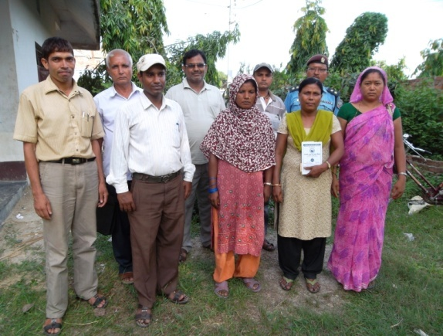
3.1.2 VDC Level Project Advisory Committee (VPAC) Formation
VPAC Kushaha, Saptari
With an aim to promote coordination and cooperation among local youth, women, VDC including other stakeholders of VDC for conducting peace building and development activities, VDC level Project Advisory Committee has been formed in 15 VDCs. The table below presents the data of VPACs formed during this quarter.

  - Training of Trainers (ToT) for Youth Leaders

I learned the methods of conducting training in this training. I can conduct the training but it became difficult for me to speak in front of the mass as I never stood in front of such big mass". Ganesh Yadav; participant
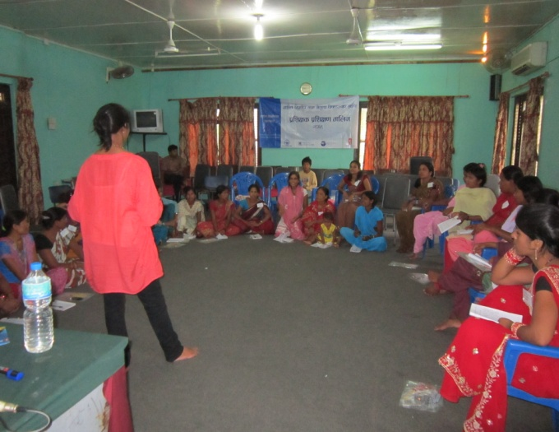
SFCG and Samagra organized 4 day training of trainers in VDRC, Nawalparasi from 9th July to 12th July. 21male youths and 8 female Youth Leaders (please see participants list in annex) and 22 women leaders (please see participants list in annex) from 20 VDCs of four districts namely Siraha, Saptari, Dhanusha and Mahottari participated in the training. The participants were from different community and professions (please see participants individual profile; individual profiles has been sent in the report of June). All the participants were selected on the basis of certain criteria (please see the report of June).
ToT women participants knowing who I am
The purpose of the training was to train youths and women leaders to design and run youth leadership for peace building training in the VDC level. The training covered leadership, training, peace, conflict and violence etc (content has been attached separate document)
"It became little bit difficult for me to understand content due to large number of participants. However I can conduct training in the VDC". Poshan Yadav; one of the ToT Participants
"It is the first time I have attended this sort of training. I understood all the things but need assistance to conduct training in the VDC". Asni Lama; one ToT participant.
"I understood the content of the training but need refreshing coaching before conducting training in the VDC". Manju Shreshtha; ToT woman participant from Dhanusha
"I can conduct training but it would be useful if there is refreshing coaching for me". Shrawan Paswan Youth ToT from Kushaha Saptari.
Group discussions, demonstration, role play, story-telling including several other methods were used during the training. Since it was ToT , training was focused on ToT methods. It focused on knowledge, skill, attitude and behavior of the participants. They were encouraged and offered opportunity for facilitation in group session. It particularly helped build confidence to those participants who had never facilitated a session.
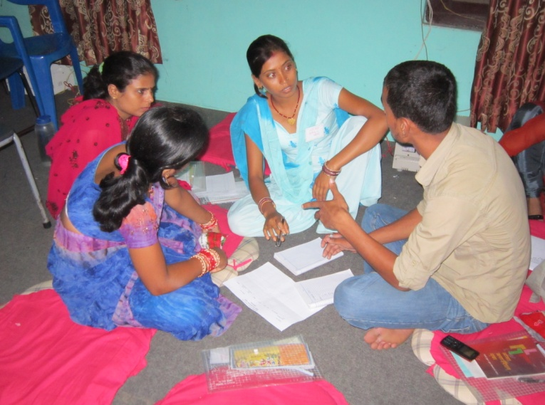
Group formation and group work during the ToT was beneficial. It provided the participants from different background and community with an opportunity to work together and group learning. It helped women participants particularly those who fear facing and hesitate to speak in the mass, to expose and practice facing the mass. ToT was useful in providing knowledge on leadership, peace, conflict, and resource mobilization etc and also in developing individual confidence, knowledge and skill. A particular topic was given to participants as group work and made present in the training. They were given feedback on their presentation and encouraged them for better performance in future. Group work and presentation made the participants realize their individual weakness and need for improvement.
ToT participants from youth and women busy in group work
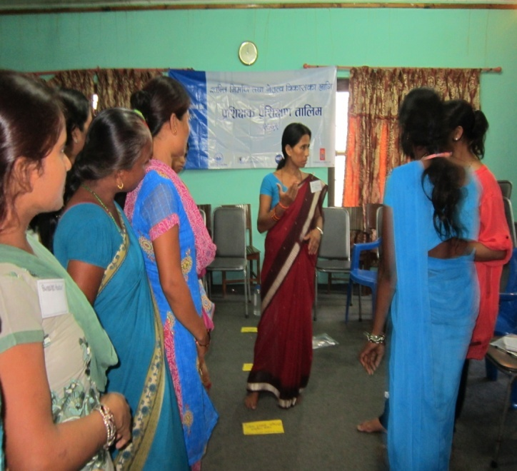
"I previously thought that I can do and I was clear what I am going to do during the presentation but when I stood in front of the mass, I was completely off and unknown of what I was doing. I forgot all that I had planned and prepared and started doing another thing in my own way. But I still believe that I can do for that I need to practice. I will take help from Samagra team in future and conduct training in my VDC". Janardan Chaudhari, ToT participant Siraha.
ToT helped women and youth participants identify themselves as a youth or women individual. Role play as a VDC secretary and women group made the women participants realize the role they can or should play in the VDC and also the way they h ave to deal with VDC secretary as well as other stakeholders.
The training was useful in understanding the leadership and identifying leadership within oneself. The participants sought to clear who they are and find leadership and its potentiality within themselves. Introduction of N-Peace nominees and N-Peace award in ToT helped the participants realize that leaders are around them or in local level too and can find even within themselves.
Women ToT Participants in the role of VDC secretary and target group
"I will share all that I have learnt here during this four day training with friends like me in the village. I am thankful to you for providing such an opportunity to me; a rural women". Sangita; ToT participant.
"I have learnt ToT methods here. I will use it in my community". Sankar Yadav ToT Dhanusha.
"This training has helped build my confidence to move forward. I will share my learnings here with my friends in the community". Urmila, ToT Participant Siraha.
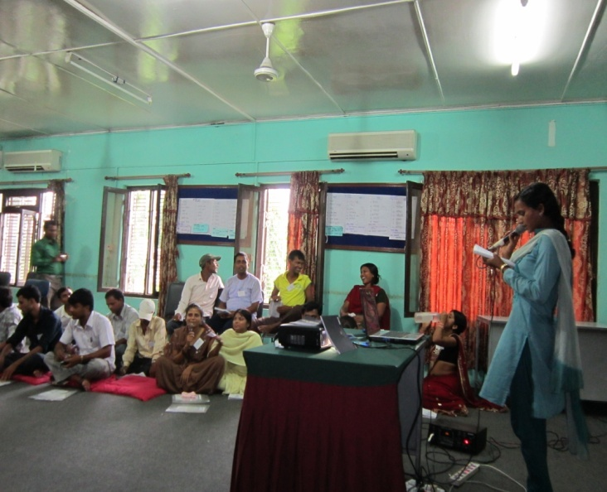
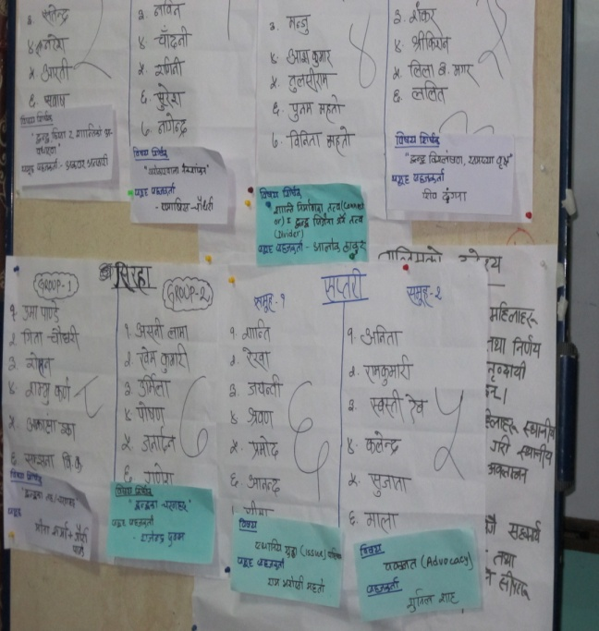
Ne twork building, local resource mobilization and government policy regarding target groups encouraged the participants build and work in network and also seek and access to local resource. Participants said that there is less participation in the local decision making level due to lack of information, and unity in youth and women. ToT has given the clear picture to the participants of what they are to do or going to do after going back to their respective VDCs. They also prepared their action plan and presented in the group. So ToT provided the participants knowledge, skill as well as clear road map too.
Making presentation in ToT
Making group for group presentation ToT
4. Community Orientation
Community orientation on subjects such as local resource and access of youth and women, good governance, role of youth and women in local development and peace building etc was organized in 16 communities of four districts.
The purpose of the orientation programs was to make youth and women aware of government policy on VDC level budget allocation, of role of youth and women in development and peace building and of good governance.

One of the women participants said, "Women should be participated in upcoming program"
"Women here are not united. They are not aware of budget to women in the VDC. Women are back due to lack of information. We got informed of budget to women. We now try to get united". Women participant
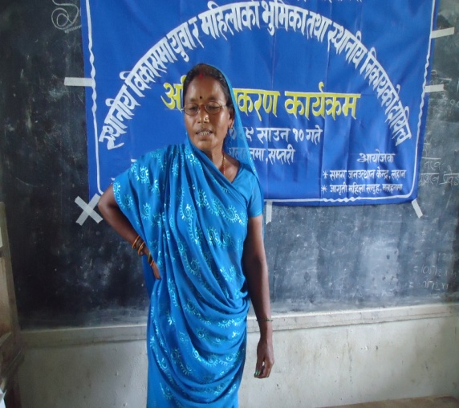
After the orientation in 16 VDCs, it was found that large number of youth and women are not aware of budget to target group in the VDC. Certain number of women does have access to information on budget. One of the social mobilizer said, "We have got budget release from VDC but not spent yet. It will be spent as planned". From this, it is clear that information on local resource and government policy, has not reached to large number of women in the society. Only few of those who have access misuse the budget. But large number of women still does not know who, how and on them the budget is spent. Women participants asked the VDC secretary about women budget in the VDC. The orientation program played vital role in providing information and creating awareness in youth and women on local resource and issues of participation.
Woman participant speaking at the orientation program
"I knew that women also have rights to VDC budget from this program. I felt the need of youth unity". Pooja Chaudhari; female youth participant from Malhanma Saptari.
"Youth and women should be involved in all the activities of the VDC". Women participant in Bishnupur katti.
"We youths will work being united in upcoming days". Youth participant in Bhadaiya
"I came to know what good governance is and its linkage with development and peace". Youth participant from Bengadowar Dhanusha
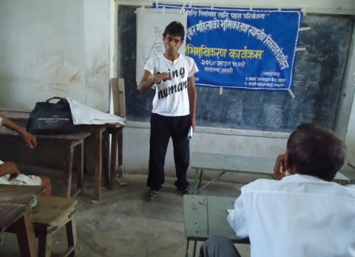
Youths participants stressed on the need of youth involvement in local resource mobilization and development activities. Youths are found serious on unemployment and issues of youth participation in local development activities. They think that there is linkage between youth involvement in local development and brain drain.
Youth Participant speaking at the orientation program
"If youths are involved in development activities, the problem of brain drain will be solved in Nepal". Youth participant of orientation program
"I understood that constructing road or bridge only is not development. It is also people's participation, human rights and freedom. In essence, development also covers overall aspect of human development'. Youth participant from Santipur Dhanusha
During the orientation program, participants demanded women budget to VDC secretary. And VDC secretaries took women and youth interests positively. They responded that if women come being united then as provision allows, budget will be allocated to women.
"We will allocate budget to women in future". VDC secretary Sasula
"If women come united, budget to women can be allocated to women". Secy Bishnupurkatti
"I have not yet received any proposal from target group in this VDC. If you come with proper proposal, I will allocate budget to you". VDC secretary Bhadaiya.
Other stakeholders in the VDCs were found positive in issues of women and youth participation. They accepted youth and women as development partners, as change receiver, seekers and makers.
"Stakeholders should not see youths in a negative view, if they are doing or going to do good things then all the stakeholders should support them". Incharge police post Bishnupur katti.
5. Outcome and Accomplishment
The activities in the first month of this quarter were focused on the VDC survey, club mapping and women group selection. Samagra focused on project advisory mechanism formation in the district and VDCs in June. Community orientation was conducted with an aim of awareing community of government policy, local resources and peace, development and good governance. The third month was focused on the youth and women leaders' ToT.
- District and VDC level Project Advisory Mechanism formed. It has created an opportunity for coordination and cooperation for TPI project. It has also enhanced the possibility of upgrading project performance standard, of collaborative work among stakeholders and prepared ground for receiving inputs and feedback for the project itself and development and peace building efforts or activities of governmental and non governmental agencies in the district.
- Youth and Women leaders have been identified and their leadership potentialities enhanced through 4 day ToT. The participants learned ToT methods, skill and knowledge on leadership, peace, and conflict analysis. ToT could also succeed to some extent to create an opportunity for participants who were not used to communicate with mass and outside world. In particular women participants who were not used to speak in the mass could at least stand in front of mass and utter few words. This was quite different from the trend that women in terai usually practice or face. Group work and role play could make the participants realize their role, responsibility in collaborative work and skill to deal with stakeholders in the VDC.
- Orientation program in 16 communities on various issues such as peace, development, good governance, local resources, and government policies could orient large section of youth, women as well as stakeholders and other sections of people in the VDC. Women and youth know government policies on them and local resources available to them. They also came to know the procedure to get access on them. Youths and women who were not in groups or united are excited to join or form a club/group and approach to local resource. Women participants who normally do not speak in the mass, the orientation programs encouraged them to speak and share their problems and issues with other section of people in the community. This has played greater role to get women and youth voice heard by concerned stakeholders and in particularly political parties and adult people. The VDC secretary and other stakeholders have responded positively to the voice of youth and women. They have committed that if women and youth come in group through due process, they will be provided access on local resource.
6. Challenges and Lesson Learned
"VDC secy does not want to give budget to political parties and political parties do not want others to work in the VDC". Participant of orientation from Sonmati Majhaura
"VDC secretary was beaten by political parties for he gave all the budget to youths", Akwar Ansari DC
During this first three months, project encountered several challenges. Some of them are as follow;
- The project started towards the end of the fiscal year of Nepal. As every year, local government agencies remain busy in development activities towards the end of the fiscal year. This makes difficult to get appointment from and meet VDC secretaries, and personnel DDCs. During VDC survey, it became difficult to obtain data from VDC. In addition to it, training for LDM had to be postponed as LDMs had no free time till August second week.
- Monsoon also affected project activities particularly training. It was difficult to convince participants for participation in the training. As it is in the middle of the monsoon, date for VDC level trainings had to be shifted for another date.
- Although there is legal no political mechanism in the VDC to control and distribute budget now, there is still strong influence and dominance of the political parties in resource mobilization of VDC. There are still several VDCs where women do not have knowledge of women budget. They are away from access to information of resource of the VDCs. Women budget is spent by male and in other development activities. There is no participation of women and youth in decision making process. So it is a challenge to empower women and youths to get access in information of government policy and resource and for participation in decision making process and resource mobilization. Similarly, changing attitude of LDMs, political parties and other stakeholders positively and increase receptiness towards women and youth and regarding local budget distribution and mobilization appears a big challenge.
- Resource is one of the reasons of conflict. And in some VDCs writ has been filed in DDC against VDC secretary as he allocated budget to youths. Society still does not have trust over youths. Youths are divided in line with political parties. Unemployment is their major problems. So uniting youths and linking peace building program with income generation is a challenge.
- Society is still not so liberal towards women. Cultural, social and religious barriers are there that is lessening the possibility of women empowerment. It is not so easy for women to come out four walls of the house. Women are asked what you brought from the program and are said that they could earn something or finish work if they went to work. Similarly, they do not dare speak in front of their seniors and mass. Lower education and lack of awareness have cut down the possibility of women participation in decision making level. They have been supporting points for male to underestimate women. So males decide in behalf of women. Changing this imbalance power relation and male psychology, attitude and behavior is very much challenging.
- ToT Participants were selected in a hurry. Compiling and timely correction on the participant list could not be made in advance as name list of the participants could not be received on time from the field. Selection process was more focused and based on the questionnaires. Their real strength and potentiality for leadership could not be discovered well. Two or three personal meeting was not sufficient for selecting good candidate. So it was learned that at least one or two interaction or orientation programs need to be organized to identify potential leader in the VDC. If it were done, good participants could be selected for ToT. So making ToT Participants able to conduct training by building their capacity has been a challenge now.
- It is also learned that the number of participants should not be large. Large number of participants directly affects the quality of the training. Two training (youth and women leadership) was merged with aim to create an opportunity for youth and women leaders for rapport building and enhance the chances of mutual cooperation and coordination but it did not happen as aimed due to participants' knowledge level variation. In addition, gender balance was an issue in the training. Selection of women participants indirectly motivated for being bias in youth participants selection process. Male participants from youth clubs were given more priority and female youths were not considered because of women ToT participants. It created confusion that women participants are already selected so no need now for selecting any female youth participants from youth clubs. As a result large number of male youths was selected from youth clubs. This created gender imbalance in youth participants of ToT.

7. Outputs Table
S.N. | Activities | Deliverables | Status at the time of Report Submission
1. | VDC survey | 20 VDCs selected | Completed
2. | Youth Club and Women Group Mapping | 19 youth clubs and 13 women Groups selected | One youth club and seven women groups will be formed after VDC level training
3. | Y&W ToT Participation Selection | 21 Male youths, 8 female youths and 23 women selected for ToT | completed
4. | DPAC Formation | DPAC in two districts namely Siraha and Saptari formed | DPAC formation in Dhanusha and Mahottari is in pipeline
5. | VAPC Formation | 15 VPACs formed | VPAC formation in 5 VDCs are in pipeline
6. | Dialogue | One held | Ongoing
7. | Orientation | In 15 VDCs held | Ongoing
8. | FGD on Farakilo Dharti | In 3 districts held | Ongoing
9. | Youth ToT | 21 Male youths, 8 female youths trained for ToT | Completed
10. | Women ToT | 23 women ToT trained for ToT | Completed
11. | Sangor Listening Session
12. | Hamro Team Screening

8. Plan for the Next Quarter
- LDM Training will be complete.
- VDC level Training to youth and women will be complete.
- Seed grant activities will start and continue till October.
- Regional level training for women leaders will be complete.
- VPAC and DPAC formation will be complete.
- Peace Club formation will be complete.
- One orientation in each working VDCs will be complete.

9. Financial Report
Detailed financial report has been attached as a separate document.

Annexes
Annex 1. Training of Trainers for Women Leadership
Date: 9-12th July, 2012 venue: VDRC Nawalparasi
Participants Name List of TOT for Women Leadership
(1) District : Siraha |  |  |  |  |  |  |  |  |  |  | Zone : Sagarmatha
S.N. | Participants |  | Address |  |  | M/F | Age |  | Group/Org. Name |  | Designation |  | Mobile N.
1 | Uma Devi Pande |  | Badharamal |  |  | F | 35 |  | Jagriti Mahila Samuha |  | President |  | 9814791791
2 | Gita Chaudhary |  | Sonmati majhaura |  |  | F | 33 |  | NOT |  |  |  | 9842870923
3 | Asni Lama |  | Bishnupur katti |  |  | F | 29 |  | Sungabha Mahila Saving & Creadit Co. Ltd. Samuh |  | President |  | 9808690600
4 | Khem Kumari Sing |  | Bhadaiya |  |  | F | 25 |  | Not formed |  |  |  | 9842824493
5 | Urmila Singh |  | Arnma Pra. Pi. |  |  | F | 35 |  | Mahila Bikash Samuh |  | Secretary |  | 9842988731
(2) District : Saptari |  |  |  |  |  |  |  |  |  |  | Zone : Sagarmatha
S.N. |  | Person |  | Address | M/F |  |  | Age |  | Group/Org. Name |  | Designation |  | Mobile N.
1 |  | Shanti Paswan |  | Kusaha | F |  |  | 26 |  | Samudayik Bikas Sewa Kendra |  | Member |  | 9816734707
2 |  | Rekha kumari chaudhary |  | Haripur | F |  |  | 27 |  | Dip jyoti Mahila samuh |  | Tresurer |  | 9804711189
3 |  | Jayanti Biswas |  | Malahanma | F |  |  | 28 |  | Mahila jagriti Samuh |  | Tresurer |  | 9804703823
4 |  | Anita Sah |  | Mohanpur | F |  |  | 23 |  | Mahila sashaktikaran Karykram |  | Secretary |  | 9817705268
5 |  | Bindu Neupane |  | Bakdhuwa | F |  |  | 34 |  | Mahila Jagarn Samaj |  | Tresurer |  | 9804785386
6 |  | Swastik Deo |  | Rajbiraj | F |  |  | 30 |  | DDC, Saptari |  |  |  | 9805905844
(3) District : Dhanusha |  |  |  |  |  |  |  |  |  |  | Zone : Janakpur
S.N. |  | Person |  | Address | M/F |  |  | Age |  | Group/Org. Name |  | Position |  | Mobile n.
1 |  | Chanda Paswan |  | Debdiha | F |  |  | 21 |  | Shree shalhesh mahila Samuh |  | President |  | 9807812350
2 |  | Babita Yadav |  | Ramdaiya | F |  |  | 19 |  | No groups
3 |  | Manju Shrestha |  | Bengadawar | F |  |  | 21 |  | Shrijana nagarik Sachetana kendra |  | Facilitator |  | 9807818988
4 |  | Rita Devi Yadav |  | Godar | F |  |  | 28 |  | Jay ma durga saving and cooperative |  | Screatory |  | 9841242461
5 |  | Mintu Das |  | Shantipur | F |  |  | 20 |  | No groups
6 |  | Binita Devi Mahato |  | Bengadawar | F |  |  | 23 |  | Shree mithilia Youth club |  | Vice President |  | 9816815215
(4) District : Mahotari |  |  |  |  |  |  |  |  |  |  | Zone : Jankapur
S.N. |  | Person |  | Address | M/F |  |  | Age |  | Group/Org. Name |  | Position |  | Mobile N.
1 |  | Sangeeta Thakur |  | Bathanaha | F |  |  | 29 |  | Mahila Utthan Samuh |  | Member
2 |  | Sunaina Thakur |  | Suga | F |  |  | 23 |  | Mahila Chhamta Bikas Shanti Samuh |  | President |  | 9819812174
3 |  | Chandani Kumari Thakur |  | Nainhi | F |  |  | 21 |  | To be formed |  |  |  | 9819831883, 9804800000
4 |  | Binita Thakur |  | Banauta | F |  |  | 23 |  | To be formed |  |  |  | 9814858383
5 |  | Priyanka Chaudhary |  | Sahsaula | F |  |  | 18 |  | To be formed
6 |  | Ram Dulari Thakur |  | Banauta | F |  |  | 22 |  | To be formed |  |  |  | 9814858383

Annex 2: Training of Trainers for Women Leadership
Date: 9-12th July, 2012 venue: VDRC Nawalparasi

(1) District : Siraha |  |  |  |  |  | Zone : Sagarmatha
S.N. | Person | Address | M/F | Age | Youth Club Name | Position | Mobile N.
1 | Rohan Ghimire | Badharamal | M | 27 | Seep Nepal | Ex. B. Member | 9814715445
2 | Sambhu Kumar Karn | Sonmati majhaura | M | 24 | Jana Kalyan Yuba Club | Ex. B. Member | 9806302209
3 | Ganesh Kumar Yadav | Bishnupur katti | M | 20 | Janaprayash Samudayik Bikash Kendra | Ex. B. Tresurer | 9807762424
4 | Janardan Chaudhary | Bhadaiya | M | 25 | Sunaulo Bihani Youth Club | Ex. B. Member | 9807714145
5 | Poshan Kumar Yadav | Arnma pra. pi | M | 35 | Yuwa Yakta Club | President | 9842835150
6 | Samjhana BK | Bhadaiya | F
7 | Akanchha Jha | Bastipur VDC | F | 20 | Youth Journalist |  | 9815773855
(2)District : Saptari |  |  |  |  |  | Zone : Sagarmatha
S.N. | Person | Address | M/F | Age | Youth Club Name | Position | Mobile N.
1 | Shrawan Paswan | Kusaha | M | 24 | Samudayik Bikas Sewa Kendra | President | 9816734707
2 | Pramod Ram | Haripur | M | 30 | Dalit Utthan Sanrkshan Kendra | President | 9807733138
3 | Birendra Kumar Paswan | Malahanma | M | 30 | Not |  | 9804703823
4 | Kalendra Chaudhary | Mohanpur | M | 23 | Bhagyashali kishor kishiri yuwa sangam | Member | 9807771845
5 | Sujata Paudel | Bakdhuwa | F | 21 | Samudayik Sewa Manch | Tresurer | 9804730905
6 | Sima Biswakarma | Kusaha | F | 20 | Samudayik Bikas Sewa Kendra | Member | 9815731128
7 | Mala Karn | Rajbiraj | F | 24 | Youth Journalist |  | 9842852288
(District: Dhanusha |  |  |  |  |  | Zone : Janakpur
S.N. | Person | Address | M/F | Age | Youth Club Name | Position | Mobile n.
1 | Lalit Kumar Yadav | Laxmipurbagewa | M | 26 | Shri Brahama Baba and Biswakarma youth club | President
2 | Aash Kumar Paswan | Debdiha | M | 29 | Shree Shalhesh Youth Club | President | 9807812350
3 | Shankar Yadav | Shantipur | M | 29 | Shree Nabdurga Youth Club | Screatory | 9807824951
4 | Tulsiram Yadav | Ramadaiya Bhawadi | M | 23 | Shree Laliguransh Charpate Youth club | Tresurer | 9804881182
5 | Shrikisun Mahato | Bengadawar | M | 19 | Shree mithilia Youth club | Member | 9815833427
6 | Lila bahadur Magar | Godar | M | 25 | Shree Samaj Sewa Youth Club | Member | 9816842695
7 | Punam Mahato | Bengadawar | F | 19 | Shree mithilia Youth club | Member | 9815844868
District:Mahottari Zone : Jankapur
 | Person | Address | M/F | Age | Youth Club Name | Position | Mobile N.
1 | Satendra Yadav | Bathanaha | M | 21 | Hanuman Youth club | Member | 9804845206
2 | Nagendra Paswan | Suga | M | 28 | Shree Krishana Youth Club | President | 9804848137
3 | Nabin Kumar Mishra | Nainhi | M | 29 | Shree Nainhi Yuwa sewa samiti,Nainhi-2 | President | 9807890990
4 | Baliram Yadav | Banauta | M | 28 | Asal Nagrik Yuwa club –Banauta-1 | President | 9814858383
5 | Naresh Chaudhari | Sahsaula | M | 30 | Shree Mithala Youth Club Sahsaula | President | 9814893059
6 | Suresh Kumar Thakur | Bathanaha | M | 28 | Youth Network for Peace Development ,Mahottri | President | 9804845228, 9844016228
7 | Raginee Jha | Suga | F | 28 | Shree Krishna Youth Club |  | 9815818794
8 | Aarti Yadav | Sonaul | F | 21 | YNPD Mahottari | Volunteer | 9844031058
