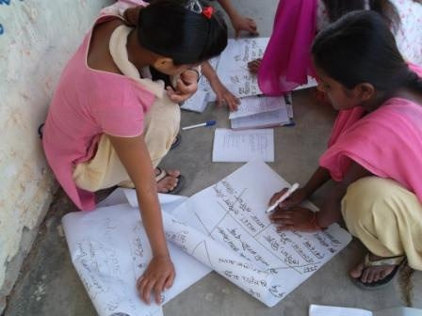
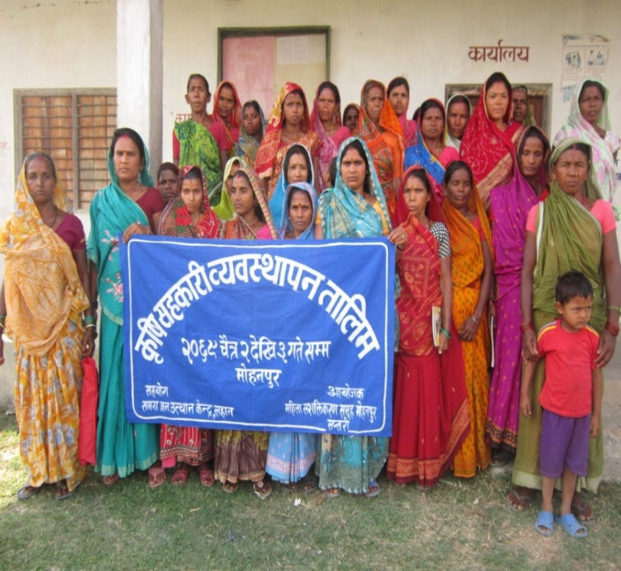
The Peace building Initiative (TPI) East: Youth and Women as pillars of Peace in Eastern Terai

PROJECT COMPLETION REPORT

SUBMITTED BY
All Peoples’ Development Centre (APEC) Siraha Lahan

SUBMITTED TO
Search for Common Ground, Nepal

PROJECT PERIOD
1st May, 2012 to August 30, 2013

DATE OF SUBMISSION
November 12, 2013

CONTACT INFORMATION
Rajendra Subba Project Manager Mobile: 9841380550 Email: rajendrasubba@gmail.com
EXECUTIVE SUMMARY
The Peacebuilding Initiative (TPI)-East was continuation but scale up project of the two previous projects entitled “Women in Community Peacebuilding and Youths in Community Peacebuilding” implemented by All People Development Centre (APEC) in financial support of Search for Common Ground (SFCG), Nepal in Siraha, Saptari, Dhanusha and Mahottari since 2008. The project covered 20 VDCs—5 VDCs from each—of four districts: Siraha, Saptari, Dhanusha and Mahottari. TPI started in 1st May of 2012 and came to end in the last of September 2013. The overall goal of the project was strengthening the role of women and youth in Eastern and Central Terai in local level peace and democratization processes through increased participation in decision-making. In addition to it, with aims of promoting sustainability business plan initiated by local youth clubs and women groups of the working VDCs of four districts and enabling them to take leadership in community peacebuilding and development activities sustainably, an additional seed grant along with capacity building trainings, orientation and other technical supports was provided to those youths clubs and women groups who had started income generating activities–like candle–making, cooperatives and vegetable–farming etc with the seed grant provided to them in the first phase of seed grant support. The specific objective of the project is to engage women and youth in the income generating activities, and to foster constructive engagement of them with local decision makers that support the peace processes at the local level.
20 different activities along with capacity building trainings and seed grant were carried out to achieve the aforementioned objectives of the project. The results of the project are encouraging. The youths and women have been able to contribute community peacebuilding through newly learned knowledge and skill of conflict mediation and dialogue. Their access to VDC resource and participation in the decision-making has increased. The youths and women have been more aware of local resources—particularly budget to women—, local resource mobilization guidelines, and local planning process and this has motivated them to take participation in the local decision-making and development activities. The youths and women have been able to lead small entrepreneurship in their leadership and initiation. More than 9 cooperative and micro finances have been established and run by the youths and women and they have been doing collective vegetable and fish farming. They are also producing and selling candle, soap, and incense-stick. The collaboration among the youths, women and local decision-makers has been possible. The VDC secretaries have supported initiatives of youths and women for community peacebuilding.
Although, youths and women have initiated for sustainable projects like cooperatives for economic empowerment of youths and women to enable them to lead and contribute community peacebuilding, their initiatives for income generation and community peacebuilding are at the initial phase hence need still regular support and guidance. If they fail to receive technical guidance, their initiations are likely to come to a halt. Secondly, VDC secretaries are frequently transferred from one VDC to another after certain time period so the support of VDC to the youths and women in the present working VDCs may not be continued if the incumbent secretaries get transferred to other VDCs as the new secretaries may not be as positive as the incumbent secretaries. Similarly, the project has increase a certain level of awareness among the women about their rights and local resources, majority of the women in rural areas are illiterate and no aware of legal provision on VAW and participation in decision-making hence are compelled to live within the four walls of the house. Patriarchic society; economic dependency on their men and lack of awareness on their rights; opportunity and government policy are limiting their potential role in community peacebuilding.
So, political parties, local government agencies are required to give hand to youths and women to continue their initiation for community peacebuilding. Capacity building training on legal and policy provisions, constitutional provisions and judiciary system etc in Nepal is essential for strengthening their role in conflict settlement.

TABLE OF CONTENTS
1. Background ……………………………………………………………………………………7
2. Project Description: The Peacebuilding Initiative (TPI)……………………………………...8
3. Activities of the Project………………………………………………………………………...9
4. Sustainability Business Plan…………………………………………………………………..10
5. Activities of the Sustainability Business Plan………………………………………………...11
6. Activities & Results of the Project……………………………………………………………11
7. Activities & Results of the Sustainability Business Plan……………………………………..23
8. Impact of the projec…………………………………………………………………………...27
9. Output of the Project…………………………………………………………………………..35
10. Lesson learned and challenges……………………………………………………………..36
11. Budget………………………………………………………………………………………..39
12. Annexes
Annex 1. Proposed activities of the project
Annex 2. Proposed Activities for Sustainability Business Plan
Annex 3 Activities Carried Out and Beneficiaries
Annex 4. Beneficiaries of Seed Grant Activities
Annex 5. Participants of VDC Level Youth Leadership Development Training
Annex 5. Participants of VDC Level Women Leadership Development Training
Annex 6 Caste-wise/Sex-wise Distribution of the beneficiaries of the project
Annex 7. Partner Youth Clubs Distribution
Annex 8. Partner Women Groups Distribution
Annex 9 Newly Registered Cooperatives limited in Support of TPI Project
Annex 10 Activities Carried Out and Beneficiaries of Sustainability Business Plan
Annex 11 Participants of Cooperative Orientation
Annex 12 VDC Secretaries’ Final Evaluation Score
Annex 13. Project in pictures
LIST OF ABBREVIATION

DPAC : District Project Advisory Committee
DDC : District Development Committee
LDM : Local Decision Makers
RLWL : Regional Level Women Leaders
VPAC : Village Project Advisory Committee
VDC : Village Development Committee
WDO : Women Development Officer
LPC : Local Peace Committee
CDO : Chief District Officer
LDO : Local Development Officer

LIST OF TABLE

Table 1 : Details of TPI Project Activities
Table 2 : Details of the activities of Sustainability Business Plan
Table 3 : Training of Trainers for Leadership Development
Table 4 : Participants of the VDC Level Leadership Development Training
Table 5 : Participants of Regional Level Women Leaders
Table 6 : Local Decision Makers’ Training
Table 7 : Seed Grant Activities and Beneficiaries
Table 8 : VDC Level Orientation on Cooperative Management and Economic
Peacebuilding Activities
Table 9 : Participants of District Level Cooperative Management Training
Table 10 : Seed Grant Distribution for Sustainability Business Activities
Table 11 : Output Table
Table 12 : Output Table for Sustainability Business Plan

1. Background

Siraha, Saptari, Dhanusha and Mahottari districts are security sensitive, volatile and socio-culturally closed part of Nepal. Due to deeply seated sense of PAHADE versus MADHESI among the people, open boarder, existence of dozens of armed outfits, infiltration of youths in criminal activities including kidnapping, drugs and small arms (SALW) trafficking and various forms of violence against women, these districts are very much security sensitive, volatile and peace vulnerable. Society is not so much open and liberal towards women. They enjoy less freedom and rights as compared to other society. Large portion of women in this part of Nepal is illiterate and confined in household activities. Women have almost neil participation in decision making. Women lack social status and lack of confidence to take leadership role in the community. The baseline survey of SFCG 2011 revealed that gender stereotype prevailing in Nepali society is contributing factor to women’s lack of participation or ability to participate in leadership positions. More than 80% women have no access to VDC budget and local officials. The survey revealed that only 19% women in this part have access to local officials. The participation of women in community meeting is low. Women do not think that they have role in decision making and community peacebuilding.
Unlike women, youths (male) have been threat to peace and security in this region as they are easily manipulated by political parties and possible infiltration in more than half dozens of armed outfit active there. Youths are politically divided and easily resort violence. The youths always resort violence and threats to receive budget from VDC. But youths’ role in community peacebuilding is not seen. The survey also reveals that large proportion of youth aged 15-29 (57%) are not aware of the CPA and its role in peacebuilding.
Politics in this region is male dominated and is viewed as male-business. Unlike this, women’s participation in politics is nominal as a result; women in this region are not in local decision making. Politics have high influence in social and development sectors. Local leaders of political parties have backdoor impact on local resource mobilization. And it is always men who are the major actors in politics make the local government agencies decide what they want. But contradictorily, women who lack such capacity of influencing local government agencies are not recognized as one of the key actors of the decision making or social change.
Local governance is almost uneffective due to absence of elected representatives of the people. Local governance is run by team of civil servant who unlike elected representatives of the people lack direct accountability towards people as they are selected but not elected. They decide under the influence of local political leaders who are almost male. Budget of target group like budget to women etc is spent on other development activities rather than in the entitled community or target group in lack of participation of women in the decision making.
Against this backdrop, with an aim of strengthening the role of women and youth in Eastern and Central Terai in local level peace and democratization processes through increased participation in decision-making, one year project entitled ‘The Peacebuilding Initiative (TPI)-east was launched by All People’s Development Centre (APEC) in financial support of Search for Common Ground, Nepal.
2. Project Description: The Peacebuilding Initiative (TPI)

The Peace building Initiative (TPI) was a one-year project implemented by All People's Development Centre (APEC) in financial support of Search for Common Ground, Nepal in four eastern and central terai districts; Saptari, Siraha, Mahottari and Dhanusha. TPI started in 1st May of 2012 and came to end in the last of September 2013. The overall goal of the project was strengthening the role of women and youth in Eastern and Central Terai in local level peace and democratization processes through increased participation in decision-making. The specific objectives of the project include:
- To enhance the participation of women and youth in peace building and community led decision making,
- To increase the receptiness of local government institutions particularly VDC to include women and youth in decision making process,
- To build the capacity of women leaders at the district and regional level in collaborative leadership and dialogue and,
- To foster constructive engagement of youth and women and local decision makers in the peace process at local level.
The key result of TPI project was increased participation of women and youth in local level decision-making processes, especially at the VDC level. Other expected outcomes include:
- Increased leadership capacity of women and youth at the community level, district and regional level,
- Increased willingness and support from the local decision makers around the role of women and youth in peace building and community decision making process,
- Youth groups and women groups are empowered to undertake local peace building initiatives, and
- Increased dialogue and collaboration among youth, women and local decision makers.
Working Areas and Target Groups: The peacebuilding Initiative Project was implemented in twenty VDCs–5 from each of four districts: Siraha, Saptari, Dhanusha and Mahottari. In order to achieve the project objectives, APEC worked with target groups that follow:
- Women at the community/VDC level
- Women leaders (from politics and civil society) at the district and regional level
- Youth at the community/VDC level
- Youth leaders (from politics and civil society) at the district and regional level
- Youth journalists
- Local decision-makers including the VDC secretaries and other government officials at the VDC and district level including Local Development Officers (LDOs) and Women Development Officers.

3. Activities of the Project

There were sixteen different activities along with leadership trainings, seed grant activities, dialogue and orientations in the project (for detail, please see in annex 1). Same activities were carried out in four districts.

Table 1: Details of the TPI Project activities
S.N. | Activities | Frequency
1. | Training of Trainer (ToT) to youth | 1
2. | Training of Trainer (ToT) to Women | 1
3. | Youth Leadership Development Training | 20
4. | Women Leadership Development Training | 20
5. | Regional Level Women Leaders' Training | 1
6. | Local Decision Makers’ Training | 1
7. | Community Dialogue | 40
8. | Community Orientation | 40
9. | Seed Grant Activities | 20
10. | Radio Testimony | 10
11. | Hamro Team Screening | 15
12. | FGD on Khula Dharti | Monthly
13. | Sangor Listenership session | Monthly
14 | International Days Celebration | 4
15 | Awards for VDC secretaries | 1
16 | District Advisory Committee Meeting | 8

4. Sustainability Business Plan
With aims of promoting sustainability business plan initiated by local youth clubs and women groups of the working VDCs of four districts: Siraha, Saptari, Dhanusha and Mahottari, and enabling them to take leadership in community peacebuilding and development activities sustainably, an additional seed grant along with capacity building trainings, orientation and other technical supports was provided to those youths clubs and women groups who had started income generating activities–like candle–making, cooperatives and vegetable–farming etc with the seed grant provided to them in the previous seed grant support program.
4.1. Objectives of the sustainability business plan
The specific objective of the project is to engage women and youth in the income generating activities, and to foster constructive engagement of them with local decision makers that support the peace processes at the local level.
4.2. Expected Results:
- Increased capacity of women and youth to run the joint project effectively
- Improved perception of local decision makers and community towards youth and women.
- Establishment of profit earning business/activities in all the 20 VDCs of the four districts.
- Increased use of cooperative problem solving tolls by the women, youth, local decision makers and the community.
- Improved perception of locals towards youth and women, and they are seen as leaders in the community.

5. Activities of the Sustainability Business Plan
There were four different activities and that include: VDC Level Cooperative Management Orientation, Seed Grant for Sustainable Business Plan and Cooperative Management Training etc. (for detail, please see in annex 1). Same activities were carried out in four districts.

Table 2: Details of the activities of Sustainability Business Plan
S.N. | Activities | Frequency
1. | VDC Level Cooperative Management Orientation | 20
2. | Dialogue Facilitation Training | 1
3. | Cooperative Management Training | 1
4. | Seed Grant for Sustainable Business Plan | 10

6. ACTIVITIES & RESULTS OF THE PROJECT
6.1. Training of Trainers (ToT)
Training of Trainers (ToT) –for Leadership Development for Community Peacebuilding– was given to 24 youths and 24 women from four districts: Siraha, Saptari, Dhanusha and Mahottari. The objectives of the ToT were to develop leadership capacity in youths and women and prepare them with essential community peacebuilding knowledge and skills for taking lead role in community peacebuilding in their respective communities. Mobilizing the youths and women participants of ToT for facilitating peacebuilding training and mobilize youths and women from their communities was also the objective of the training.

Table 3: Training of Trainers for Leadership Development
S.N. | Activities | Venue | Held Date | Participants
 |  |  |  | Male | Female | Total
1 | TOT to Youth | VDRC, Gaidakot, Nawalparasi | July 9-12, 2012 | 21 | 8 | 29
2 | TOT to Women | VDRC, Gaidakot,  Nawalparasi | July 9-12, 2012 | 0 | 22 | 22

6.1.1. Achievements
24 youths and 24 women from four districts: Siraha, Saptari, Dhanusha and Mahottari received ToT skills and knowledge on peacebuilding, local resources and its mobilization guidelines, local planning process. Leadership capacity and skills of the participants was enhanced. 42 (87.5%) of the ToT participants became active in the community peacebuilding after going back to their respective communities. 20 (41%) youths and women facilitated leadership development training for community peacebuilding organized in their VDCs whereas 6 (3%) youths and women among them have been good facilitators who facilitated same type of training held in the neighboring VDCs. This training has also brought changes on the participants’ perception towards peace, violence, conflict, leader, and leadership.
6.2. Youth/ women Leadership Development Training
20 Youth Leadership Development and 20 Women Leadership Development Training was held in 20 VDCs—5 VDCs from each district—of Siraha, Saptari, Dhanusha and Mahottari districts and that trained 589 youths and 583 women on leadership skills and capacity for community peacebuilding. The purpose of the VDC level leadership development training was to transfer knowledge and skills of peacebuilding to the youths and women from the community and encourage them to take leadership role in community peacebuilding. In addition to it, the training also aimed to increase access and participation of youths and women in local decision making.

Table 4: Participants of the VDC Level Leadership Development Training
S.N. | Type of Training | Held Date  (Between) | District | Participants
 |  |  |  | Male | Female | Total
1 | Women Leadership Development Training | November 2012 to January 2013 | Siraha, Saptari, Dhanusha & Mahottari | 0 | 583 | 583
2 | Youth Leadership Development Training | November 2012 to January 2013 | Siraha, Saptari, Dhanusha & Mahottari | 376 | 213 | 589
 | Total Participants of Leadership Development Training |  |  | 376 | 796 | 1172

6.2.1. Achievement
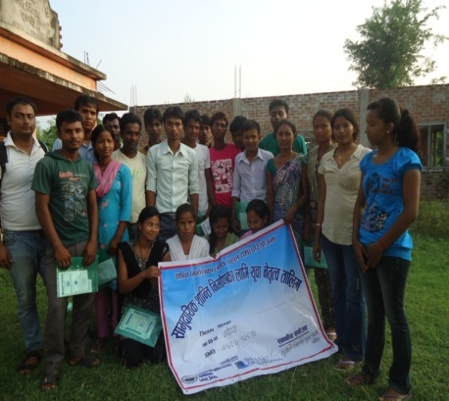
Basic skills and knowledge of conflict analysis, mediation, dialogue and common ground approach was transferred to 589 youths and 583 women of the local communities. Existing government policy of participation, inclusion as well as local resource mobilization guidelines and planning process was brought to the notice of the youths and women that encouraged the youths and women demand their entitled budget in the VDC and participation in the decision making. Besides, APEC with an aim to enrich training developed a manual for Leadership Development Draining for community peacebuilding which was useful in conducting training and used as the training materials during the training period in four districts. The trainings have changed perception towards conflict, violence and peace. The participants have received conflict management skills and knowledge and been aware of their role and CPA in peacebuilding.
Figure 1Participants of Youth leadership developement training
“I do not have any clue that government sends budget to women too. I leant it from this training. We need to spend that budget”, Basanti Devi Mandal, Mohanpur VDC of Saptari.

6.3. Regional Level Women Leaders' (RLWL) Training
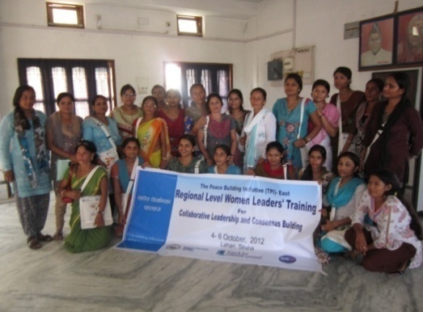
24 Regional Level Women Leaders (6 from each district) involving in different sectors from Siraha, Saptari, Dhanusha and Mahottari was trained for three days on ‘collaborative leadership and consensus building’. The purpose of the training was to enhance the skills and knowledge of the participants on collaborative leadership and consensus building’ and to encourage the women leaders to apply the skills gained in the training in their own respective field for increasing women’s leadership capacity for community peacebuilding and participation in local decision making.
Table 5: Participants of Regional Level Women Leaders
Type of Training | Districts | Venue | Held Date | Composition of the Participants
 |  |  |  | Male | Female | Total
Training of Regional Level Women Leaders | Siraha, Saptari, Dhanusha, Mahottari | Marbadi Sewa Sadan, Lahan | October 4-6, 2012 | 0 | 23 | 23

6.3.1. Achievement
The training helped sharpen 24 women leaders’ skills and knowledge of collaborative leadership and consensus building and strengthened confidence for taking effective leadership role in their respective filed. The training also facilitated sharing of different practices and perspectives that the women leaders have been doing since long.
6.4. Local Decision Makers' (LDMs) Training
Two-day long LDMs Training was held in Lahan that trained 24 local decision makers including 19 VDC secretaries, 1 WDO and two representatives of DDC and two representatives of WDO on peacebuilding; participatory decision making and development; and local resource mobilization, its guidelines and existing practices. The purpose of the training was to change the existing negative perception of the local decision makers towards youths and women and to help develop collaborative and participatory development practices, behavious and attitude in the local decision makers. The training also aimed to help the local decision makers identify local youths and women as important actors of decision making and to create space for them in the decision making accepting them as the key change agent of the society.

Type of Training | District | Venue | Held Date | Participants
 |  |  |  | Male | Female | Total
Training of LDM | Siraha, Saptari, Dhanusha and Mahottari | Marbadi Sewa Sadan, Lahan | August 16 & 17, 2012 | 23 | 3 | 26
Table 6: Local Decision Makers’ Training

6.4.1. Achievement
The training trained 24 local decision makers including 19 VDC secretaries —who always remain directly in contact with local people along with youths and women and play vital role in local decision making and resource allocation—on basic knowledge and skills of peacebuilding and participatory development, decision making and good governance. The training was useful in exchanging views, opinions, challenges and practices that local decision-makers from four districts: Siraha, Saptari, Dhanusha and Mahottari have been doing in their respective districts and VDCs. The training developed also provided common platform for youths and women from the same VDCs and districts that LDMs came from to discuss the existing problems in the VDC and to understand each others’ interests and position on addressing the problems with VDCs secretaries. The training provided an opportunity for youths, women and VDC secretaries to work on score card who mutually agreed the process and criteria of evaluation to develop a score card and developed one in order to use in evaluation of VDC secretaries’ initiation, effort and response for addressing the issues and concern of the youths and women during the project life.
"I would allocate budget to youths from the budget to target groups. I will help the youths if they come to be for a noble cause". Bhagawat Prasad Yadave; VDC Secretary, Mohanpur, Saptari
6.5. Community Orientation
Community orientation on the subjects: good governance; participatory development; role of youths and women in the development and peacebuilding; constitution assembly and participation of youths and women etc was conducted in 40 places of 20 VDCs of Siraha, Saptari, Dhanusha and Mahottari. The community orientation aimed at increasing awareness among the youths and women on good governance, participatory development, their role and importance in community peacebuilding and development and importance of CA election and participation of the youths and women. The community orientation program oriented 1212 youths, women and political leaders and other members of the community.
6.5.1. Achievement
The orientation program oriented 1212 youths, women, local leaders of political parties including other members of the communities in 20 VDCs on local resources, local budget mobilization guidelines, participatory development and importance and role of youths and women in community peacebuilding and development. The orientation also helped bridge the gap between youths-women and VDC secretaries and also local leaders and youths-women and facilitated open communication on issues of development and resources. Youths and women became more aware of their budget and rights to have access to resource and participation in decision making. This encouraged youths and women demand their entitled local budget and participation in decision making as a result more than half dozen VDC secretaries allocated budget to youths and women and dozen more VDC secretaries started formally inviting youths and women in VDC meetings.
6.6. Community Dialogue
40 community dialogues were convened in 20 VDCs of four districts that involved 1070 key persons in the communities including youths, women, local political leaders, civil society leaders and local decision makers-VDC secretaries- dialogue process on different issues-like development, participation of youths and women in decision making and development activities, good governance and CA election etc. The purpose of the dialogue was to bring people including youths, women, local political leaders and civil society leaders and those who were divided in different political lines, ethnicity and interest groups to a common forum and to encourage them share their opinion, view, interests, positions and understanding on the existing issues to develop a common and mutually acceptable options and understanding to address the conflicting issues of the community.
6.6.1. Achievement
Community dialogue could provide common forum to the people divided in different political interests, ethnicity and pressure groups to share their understandings, perspectivies, opinitons, interests and positions on issues-like corruption, participation of women and youths in development, community peacebuilding and decision making and role and importance of youths and women’s participation in the community development and that helped develop common understanding and option to address the issues properly. The dialogue engaged 1070 key people including youths, women, local leaders of political parties and VDC secretaries. The dialogue bridged the intergeneration gap and facilitated open communication among youths, women, VDC secretaries and local leaders of the political parties.
6.7. Seed Grant Activities
Support of 10,000 NRs was provided to each of the youth clubs (20) and women groups (20) of 20 VDCs as the seed grant. Total amount of 400,000 NRs was distributed to youth clubs and women groups based and actives in 20 VDCs of four districts: Siraha, Saptari, Dhanusha and Mahottari. The purpose of the seed grant was to provide support to their initiation or action plan for further empowerment of youths and women, leadership development and community peacebuilding and to help them establish in the leadership position in the community.
No of Implementing Youth Clubs and Women Groups | No of Seed Grant Activities Carried out | Geographical Coverage | Total Amount of Seed Grant Supported | Beneficiaries of the seed grant
 |  |  |  | Male | Female | Total
20 clubs  20 women groups | 33 | 20 VDCs of Siraha, Saptari, Dhanusha and Mahottari district | 4,00,000 (NRs) | 436 | 818 | 1254
Table 7: Seed Grant Activities and Beneficiaries

6.7.1. Achievement
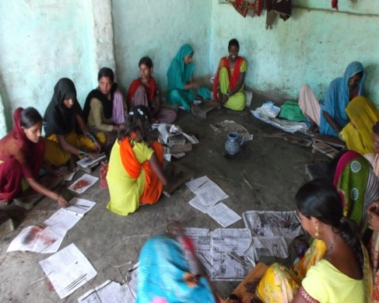
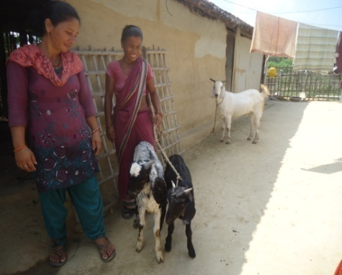
Seed grant activities carried out by the youth clubs and women groups in support of APEC were more focused on economic empowerment, capacity development, and collaborative leadership. The youth clubs and women groups in 8 VDCs spent the seed grant for running a new cooperatives led by them. They spent grant which consists 15 out of 40 on basic level of cooperative management training, registration and legal document process and remaining as the share of the cooperative. Women groups in two VDCs spent the grant for the further improvement, development and registration of the cooperatives that they have already been running in the VDC. 16 seed grants were spent on income generating skill trainings. These trainings include: soap-making, candle-making, incense-stick-making, chair-making, pickle-making, paper-making, sewing and computer training. 8 clubs and groups utilized seed grant on leadership development, collaborative work and capacity building training for peacebuilding.
Figure 2 Youths and women Incense making
1254 youths and women along with 436 male and 818 female were directly benefitted from the seed grant activities. 9 youths and women-led cooperatives were registered whereas one was further improved from the seed grant. Small income generating trainings such as soap-making, candle making, pickle and paper-making and bamboo chair-making etc were held in 10 VDCs and youths and women were trained on them. And youths and women in 5 VDCs are commercially producing candle, incense, chair and soap now. (For details, see annex 4)
6.8. International Days Celebration
Four international Days: International Peace Day, International Human Rights Day, International Youth Day and International Women Day, were marked in Siraha, Saptari, Dhanusha and Mahottari on their particular day in collaboration and coordination with government agencies and non government organizations. 1541 youths, women , civil society leaders, government officials, security personnel and ordinary people together with marked the days both in the district headquarters and villages. The purpose of marking the international days was to earn solidarity among the people involved and divided in different professions, sectors and geography for promotion and protection of human rights, peace and democracy in the globe. The day observation also was for making the concern authority ensure the rights, peace and full democracy and warn the spoilers that youths, women and other stakeholders are united for protection of rights, peace and democracy.
6.8.1. Achievement
The observation of the international days earned solidarity among the people involved and divided in different political parties, professions, interests and geography for the protection and promotion of human rights, peace, and democracy. Secondly, the celebration of the days developed cooperation, trust, coordination and direct communication between and among the government and non government agencies. It encouraged government and private sectors along with different political leaders, youths and women stand in one place and voice for the common cause of human being. The day marking also imparted message of human rights promotion, full democracy and peace to the people living in the grassroots level.
6.9. Awards for VDC secretaries
Four VDC secretaries-one from each district- were awarded with NRs 25,000 and appreciation letter for their contribution, role and initiation in increasing participation of youths and women in local decision making and access in local resources; supporting youths and women’s initiation for community peacebuilding and development; and collaboration with youths and women for promoting peace, democracy and good governance in the VDC. 16 other VDC secretaries were also awarded letter of appreciation acknowledging their role for increasing participation of youths and women in decision making. The purpose of the award was to encourage the VDC secretaries to increase participation of youths and women in decision making, and development activities; to support initiation of youths and women for community peacebuilding and development; and to promote culture of collaborative efforts among the youths, women and VDC secretaries for community peacebuilding and development. (Please see annex 12 for evaluation score)
"TPI project had a different focus. It particularly focused on youths who get involved in conflict. So this is very good program and we will continue this program in future, I will make commitment to do this in future too. We are very much motivated by this program and I suggest extending this program in other VDCs too in future", Baliram Yadav (Badaharamal VDC, Siraha)

6.9.1. Achievement
The award for VDC secretaries proved to be fruitful and effective in motivating the VDC secretaries for increasing participation of women and youths in decision making; supporting initiation of youths and women for community peacebuilding and development activities; and promoting culture of collaborative efforts among the youths, women and youths for peacebuilding and development. The VDC secretaries —both the winners and others—felt motivated by the award to work for youths and women. They not only expressed happiness for true evaluation of their work but also commitment to continuously work for the youths and women in their working VDCs.
6.10. Radio Testimony (PSAs)
Radio Testimony of ten exemplary persons —who made remarkable contribution for social change— from different VDCs of Siraha, Saptari, Dhanusha and Mahottari was produced and broadcasted from local F.M. stations of four districts. The purpose of collection and broadcast of radio testimony was to unveil hidden heroes—both male and female—of the local communities and their contribution for social change and to give positive message to youths and women for encouraging them to work for social change.
6.10.1 Achievement
The story of struggle for social change, and growing as young entrepreneur reached to people living six districts along with Siraha, Saptari, Dhanusha and Mahottaril through broadcast of radio testimonies from local F.M stations that brought the hidden change agent and their contribution for social change to the notice of public. They also increased public interests and curiosity on them. Story and struggle of women rights activists —like Shyam Kumari Sah, Kusum Acharya and Sunaina Thakur and Youth entrepreneur like Prakash Koirala— had a positive impact on youths and women who took initiation for running small entrepreneurship and community peacebuilding in their respective VDCs.
6.11. FGD on Khula Dharti
Focused Group Discussion sessions were held seven times in four F.M. stations—Chhinnamasta F.M. Rajbiraj, Saptari; Radio Samagra Lahah; Radio Madhesh, Janakpur, Dhanusha; and Radio Appan Mithila, Jaleshwor, Mahottari— in participation of guest speakers of the episode of Khula Dharti, its listeners and producers of Khula Dharti. The purpose of the FGD sessions was to feed issues for next episode of the radio talk show, provide feedback on program design, ways of asking questions, coverage on the topic, and output of the show etc.
6.11.1. Achievement
The FGD sessions were useful as they fed several relevant and important issues that need to be discussed in the show. They also provided feedback on selection of the guest speakers, program design, and ways of asking questions, concluding the show, coverage, output and follow ups of the progress. This helped to have and proceed dialogue process on the local and important issues with key stakeholders who tried to find common ground in addressing the problems.
6.12. Hamro Team (HT) Screening
Hamro Team—a television show on the story of football team comprising of players from different background and geography who succeeded in winning game going through individual competition, conflict, non cooperation and no coordination to cooperation, unity, collaboration and solidarity—was screened in four places among the youths studying in colleges. The purpose of the screening was to change attitudinal, behavioural and perceptional changes among the youth through the show and to encourage them to seek common ground to settle conflicts among them.
6.12.1. Achievement
The show was effective in making the youth realize that problem showed in the show was common problem of the youths in Nepal. It also made the youths realize that it is essential to respect differing opinions in the group or team to do team building. The show has been fruitful in bringing perceptional change among the youths.

6.13. Sangor Listenership session
Listenership Session of Sangor—a radio drama on youths, conflict and contemporary issues of the society which was broadcasted through local F.M. stations of Siraha, Saptari, Dhanusha and Mahottari—was held seven times in different places of four districts in the participation of the regular listenership of Sangor. The purpose of the listenership session was to identify behavioural and perceptional changes occurred due to the radio drama on the listeners.
6.13.1. Achievement
The listenership session helped to identify the behavioural and perceptional changes occurred in the youths due to the radio drama. It was also useful in feeding issues that the drama need to focus in the next episode. This provided feedbacks on keeping the character live or dead, or turning points and focus of the drama and issues that the drama has to focus in the next episode.
6.14. District Project Advisory Committee (DPAC) Meetings
District Project Advisory Committee (DPAC) was formed in Siraha, Saptari, Dhanusha and Mahottari districts in chair of chief district officers. The DPAC consisted of members representing security, local peace committee, DDC, WDO, small cottage industry, non government organizations, press and local media house. The purpose of formation DPAC was to facilitate mutual cooperation, coordination and solidarity for promoting peace, and rights of youths and women in the district. Providing feedback and technical support to the project team during the project period to enhance effectiveness of and scaling up the impacts of the project was also the purpose of the DPAC formation.
6.14.1. Achievement
The DPAC meeting held 8 times in the districts and provided several important feedbacks to the project team regarding the activities, target group, coverage and effectiveness of the project. These meetings bridged the communication and coordination gap prevalent between government and NGOs and promoted solidarity and coordination between them. Government and non government agencies - which showed solidarity in promoting peace, democracy and rights of youths and women by marking international days together-exchanged their perspectives, experiences, lesson learned and tried to address the issues of youths and women along with peacebuilding in the district.
7. ACTIVITIES & RESULT OF ADDITIONAL BUSINESS PLAN
7.1. Orientation Cooperatives Management
With an aim to develop capacity of local youth clubs and women groups' member for running cooperatives by increasing fundamental knowledge and skills of both credit and saving and Agriculture Cooperatives, one day orientation on cooperative management was held in each working VDCs of Siraha, Saptari, Dhanusha and Mahottari . (for details see annex 11.)
Table 8
VDC Level Orientation on Cooperative Management and Economic Peacebuilding Activities
Activities Carried out | Geographical Coverage | Held Date (Between) | Participant of the orientation
 |  |  | Male | Female | Total
Youth Clubs and Women Groups Orientation | 20 VDCs of Siraha, Saptari, Dhanusha and Mahottari district | July and August, 2013 | 111 | 297 | 408

7.1.1. Achievement
The orientation has increased the fundamental knowledge of cooperative management among the participants. It also brought clarity in registration process and built up confidence of the youths and women aspiring for running cooperative. The orientation further motivated and strengthened team work.
7.2. Workshop on Dialogue Facilitation and Rights to Information
Two days' workshop on "Dialogue Facilitation and Rights to Information" was held in Ananda Hotel of Janakpur from July 10 to 11, 2013. The workshop was organized as the institutional development of community dialogue centre to replace the information Panchayati system long existed in the community and capacity development of youths involved in the centre with an aim to prepare them as key persons of community dialogue facilitation and campaigners for 'right to information (RTI)' so that they would be able to convene and facilitate local disputes and conflicts and contribute to community peace building. Similarly, they would be able to run a social campaign for right to information and make local government agencies and authorities responsible towards issues of youths and women and help them get involved in decision making process.
7.2.1. Achievement
7 youths form Samagra Dialogue and Youth Information Centre, Siraha and 7 from Debdia-Ghorwash Dialogue and Youth Information Centre Dhanusha district were trained on dialogue facilitation skills and knowledge and campaign for RTI. The workshop also helped sharpen the participants' knowledge and skills of dialogue facilitation, conflict mediation, and conflict analysis, right to information movement and campaign strategies and fund raising to support the campaign.
7.3. Cooperative Management and Institutional Development Training
Cooperative Management and Institutional Development Training was given to 30 participants hailing from Siraha, Saptari, Dhanusha and Mahottari participated in the training. The training was held with an aim to develop capacity of leaders of the newly formed cooperatives under the TPI Project in four districts on cooperative management and institutional development. The training focused on the technical aspects, rules regulation, account management, and risk management of the cooperatives.
Table 9: Participants of District Level Cooperative Management Training
Type of Training | Geographical Coverage | Held Date (Between) | Participant of the orientation
 |  |  | Male | Female | Total
Cooperative Management | 20 VDCs of Siraha, Saptari, Dhanusha and Mahottari district | August 6-8, 2013 | 9 | 18 | 27

7.3.1. Achievement
The training brought conceptual and theoretical clarity of different cooperatives among the participants. The participants learnt rules, regulation, account and risk management and registration process. The participants were inspired by the success story of people like Sushil Chandra Adhikari; founder and manager of Shramjiwi Credit and Saving Cooperatives which has turnover of 33 crore and running cooperative schools and hospitals. The training built up the confidence of the participants. It also sharpened the leadership skills of the participants.
7.4. Seed Grant for Sustainable Business Plan
Additional amount of 50,000 NRs was provided to those youth clubs and women groups which succeeded in starting sustainable empowerment projects like cooperative and small entrepreneurships. Total amount of 10, 00,000 NRs was distributed to 8 youths clubs and women groups and two Youth Information and Dialogue Centers established in Debdia-Ghorwash VDCs of Dhanusha and Lahan of Siraha district.
Table 10: Seed Grant Distribution for Sustainability Business Activities
No of Implementing Youth Clubs and Women Groups | No of Seed Grant Activities Carried out | Geographical Coverage | Total Amount of Seed Grant Supported | Beneficiaries of the seed grant
 |  |  |  | Male | Female | Total
10 clubs and women groups | 10 | 20 VDCs of Siraha, Saptari, Dhanusha and Mahottari district | 10,00,000 (NRs) | 25 | 162 | 187

7.4.1. Achievement
187 youths and women along with 25 male and 162 female are involved in sustainable business plan. These youths and women are currently running cooperatives and micro entrepreneurship such as vegetable farming, fish-farming, soap-making, candle and incense-making, micro business and goat-keeping under the cooperative. Two ‘Youth Dialogue and Information Centre’ have also been established in Dhanusha and Lahan with an aim to promote culture of dialogue and conflict resolution through dialogue process by replacing traditional panchayati system long practice and existed in the communities. Providing important information on youth career development, government policy and local resources is also the objective of the centre.
The youth club and women group in Debdia and Santipur VDC of Dhanusha district and Bhadaiya VDC of Siraha district spent 50,000 NRs to formally registered cooperatives and to support 10 women members of the cooperatives for their initiation for vegetable farming and micro business. Youths and women of Santipur VDC also used 50,000 NRs to register agriculture cooperative and to support seven of its members for vegetable farming.
Similarly, in Siraha district, youths and women in Arnama Pra.Pi VDC have started producing Soap with support of 50,000 NRs. They have produced Soap worth of 12,000 and 23 women involved in it. Women group of Bandipur of Badaharamal VDC are also involved in income generating activities. Three of its members produce chair of bamboo whereas 7 of its members involved in goat-keeping with the support. Similarly women in Bishnupurkatti are also involved in goat keeping.
In Mahottari district, women group of Suga have utilized seed grant for running agriculture cooperative and promotion of mithila painting. Besides, cooperative, five of its members are doing mithila painting with the support. Similarly, youths of Suga VDC are involved in candle making. They have utilized the seed grant for producing candle. They have produced more than 200 pieces of candle so far. They sell it in the village. Youths of Banauta VDC are also running agriculture cooperative and producing candle. Seven of its members of the cooperative are involved in candle making. In Bathnaha VDC, youths and women are involved in incense-stick making. 10 of its members are regularly making incense stick and the cooperative that they have registered is helping them for marketing. They have utilized the seed grant for running cooperative and incense stick making. In Nainhi VDC, fifteen members of women group are producing incense stick. They have produced 200 packet of incense so far.
Youth club and women groups in Kushaha, Bakdhuwa, Malhanma and Mohanpur VDCs of Saptari district have registered cooperatives and supported its members for micro business, vegetable farming and goat keeping with seed grant.
8. Impact of the project

8.1. Increased leadership capacity of women and youth at the community level, district and regional level
The participants of 'Training of Trainers' (ToT)–for Leadership Development for Community Peacebuilding– have started taking social responsibilities. Shrawan Paswan–one of the participants of ToT and also the president of a CBO–Community Development Centre, of Kushaha of Saptari district– organized free Eye Camp in Kushaha Bazar in Bhadra 8 and in Sanhi VDC in Ashwin 8 of 2069 in collaboration with Sagarmatha Chaudhari Eye Hospital where more than 400 eye patients got their eyes checked and had free eye operation. Shrawan who contributed to community peacebuilding by facilitating VDC level leadership development training for community peacebuilding took initiation and registered an 'Agricultural Cooperative Limited'–Surunga Agricultural Cooperative Limited–in his own VDC with aims to unite youths and women and attract them towards small entrepreneurship through which youths and women can work collectively for strengthening their economic condition and consolidating their leadership role in the society. His cooperative has been recognized as the one led by youths and women in the VDC and is focused on youths and women's entrepreneurship development. More than ten youths and women have taken small amount as loan grant at minimal interest rate from his cooperative to support their goat–rearing and vegetable farming projects.
Training of Trainers (ToT) –for Leadership Development for Community Peacebuilding– received by 24 youths and 24 women from four districts: Siraha, Saptari, Dhanusha and Mahottari.
Similarly, Pramod Ram–another participant of ToT from Haripur VDC of Saptari district–and his organization –Dalit Empowerement Centre, Haripur– organized similar kind of free eye camp in Haripur VDC in Asad 3 of 2069 BS in coordination Sagarmatha Chaudhari Eye Hospital where more 52 eye patients got their eyes operated and more 153 eye patients got eyes checked.
Youths and women Becoming Economically Independent
Youths from Siraha, Saptari, Dhanusha and Mahottari were like in other parts of the country were always manipulated by political leaders and used for political interests in strike and other types of violence but were left isolated or sidelined during and in time of decision making and development activities a year before. Frustrated, isolated and under-representated youths in these districts like the youths from other parts of the country either used to go to foreign employment or lived in urban areas in the search of job and opportunity for higher studies. And those who could not do both used to join armed outfit and involved in criminal activities. Whereas, women unlike youths mostly used to stay at home and hardly go out to public gathering except marriage and other traditional occasions. They had no participation in decision making, and other development activities in the community. Speaking in front of elders from the village and doing some income generating activities was beyond their imagination. Many women did not participate in the public meetings and gatherings and if they did, they hardly used to speak. Whatever male members and villagers decided on behalf of women, they used to accept. They were economically dependent to their husband and family members. This dependency was one of the reasons why women could not out to public meetings or participate in the decision making and also were victim of domestic violence.
All People’s Development Centre (APEC) in financial support of SFCG, conducted youths and women leadership training for community peacebuilding to youths and women of the VDCs separately. 10,000 NRs in first phase and 50,000 NRs in the second phase were supported to youths and women as the seed grant to help them implement their action plan on youths and women empowerment for community peacebuilding program following the leadership development training. Community orientation, regular informal coaching, mentoring and involvement of youths and women in peacebuilding activities enhanced the leadership and broadened knowledge on local resources, potentialities, government policies and small entrepreneurships.
With the seed grant, youths and women groups decided to get involved in small income generating activities such as candle-making, soap-making, incense stick-making and sustainable entrepreneurship like cooperative and micro finance. Eight new cooperative and micro finance private limited have been registered and run by youths and women groups whereas one women saving group has formally been changed into cooperative and micro saving limited and one has further been improved. To support cooperatives run, and circulate capital, collective vegetable farming, soap production, goat rearing and small buying-and-selling business are also being done.
But all the youths and women initiatives for income generation and community peacebuilding are at the initial phase hence need still regular support and guidance. If they fail to receive technical guidance, their initiations are likely to come to a halt. The youths and women’s initiations are required to provide technical support till they grow matured. APEC, therefore needs to provide technical support, motivation and monitoring till they stand themselves.
It is learnt that if knowledge, skill and support is given to youths and women, youths can be involved in creative activities. Women also come out of four walls and get involved in social activities. And such activities help youths and women get united for echoing voice for their rights.

The Training of Trainers boosted leadership capacity of the participants and broadened the knowledge on local governance system. Unlike before, the participants started taking participation in VDC Meetings. Youths and women: from Kushaha, Bakdhuwa, of Saptari; Arnama Pra.Pi. Bandipur and Bishnupur of Siraha; Bengadawar, Santipur and Debdiha of Dhanush and Bathnaha and Suga of Mahottari participated in the VDC meetings.
They have been formally sent invitation letters for meeting. ToTs in Arnama Pra. Pi. are regularly attending meeting.
8.2. Increased willingness and support from the local decision makers around the role of women and youth in peace building and community decision making process
The project had a positive impact on Local Decision–Makers (LDMs): the VDC secretaries. The LDMs' training and provision of VDC secretary–award increased wiliness and support of LDMs towards youths and women. After LDM Training, perception of VDC secretaries towards youth and women has changed. The VDC secretaries who used to turn deaf ear to youth and women before the training, started participating in the programs organized by youth and women groups and showing their support and solidarity in youths' and women's community peacebuilding initiatives. They gave time to youth and women and listened to their concerns and issues. Besides, the secretaries started providing information on VDC budget, other income resource of VDC and planning process to youths and women through youths and women leadership development training and orientation programs held in the VDC. As a result, youths and women of the VDCs have been aware of the VDC resource (budget) and existing resource: budget, allocation policy. It has encouraged youth and women in community development and VDC resources. They have started queries over decision making process.
Local Decision–Makers (LDMs) training received –by 19 VDC secretaries, one Women Development Officer, two planning officers of DDC, three representatives of WDO–from four districts: Siraha, Saptari, Dhanusha and Mahottari.
The VDC secretaries publicly summoned youths and women to come with proposal to get budget and supported youths and women groups for their initiatives for community peacebuilding. VDC Secretary of Malhanma VDC of Saptari provided 90,000 Rs to Jayanti Chaudhary–one of the women participants of ToT– and her women group. Her group bought five sewing machines with the amount and provided sewing training to 41 women of Malhanma VDC. This training would be held each year in support of VDC.
Shifting Attitude of Local Decision–Makers (LDMs) towards youths and women in Eastern and Central Terai
Local Decision Makers (LMDs)–particularly Village Development Centre (VDC) secretaries–were not positive towards the issues and concerns of local youths and women in the VDCs one year ago. Women budget which by VDC resource mobilization guidelines should be spent on women empowerment in the VDCs were spent in other development activities–like electricity and road maintenance–in previous years. Women’s participation in the meetings of VDC was nominal and in many VDCs was recorded neil. Youths were never part of the meetings in the VDC. This trend in the VDCs underestimated the role, importance and potential contribution of both–Women and Youth–in the development process of the VDC.
With aims to change LDMs’ perception and attitude towards youths and women of the VDCs and encourage them to play positive role in empowering them for community peacebuilding and development, 19 VDCs secretaries along with the representatives of DDC and WDO of four districts were given two–days long ‘Local Decision Makers’ training on peacebuilding. Key youth and women leaders of youths clubs and women groups from 20 VDCs were also invited to the training for discussion with the secretaries and to develop score card together with the secretaries for the purpose of evaluating the role and contribution of the secretaries in empowering youths and women for community peacebuilding and development. VDCs secretaries were also invited in the community orientation and dialogues convened in their respective VDCs and were asked to share existing provisions of local resource mobilization guidelines, local resources particularly budget and their opinion regarding women and youths’ participation in the decision making. An award of 25,000 NRs was also declared with an aim to encourage VDC secretaries to play positive role in increasing youths and women’s participation in decision–making and community peacebuilding,. Regular consultation and meeting with VDC secretaries was also held during the project life.
This intervention made a huge impact on the VDC secretaries who publicly summoned youths and women to come with proposal to get budget and supported youths and women groups for their initiatives for community peacebuilding. VDC Secretary of Malhanma VDC of Saptari provided 90,000 Rs to Jayanti Chaudhary–one of the women participants of ToT– and her women group. Her group bought five sewing machines with the amount and provided sewing training to 41 women of Malhanma VDC. This training would be held each year in support of VDC. VDC secretary of Badaharamal of Siraha provided 70,000 Rs to Youth Club: CEEP Nepal Bandipur. The club started Gym Club there with the amount with an aim to unite youths divided politically and prevent them from being involved in conflict and drugs addiction. Women group of Bishnupur VDC of Siraha district also received 54,000 Rs from the VDC. They spent the amount on ‘Legal Empowerment and Awareness for Women’ residing in nine wards of the VDC. Basic Level Training on Cooperative—organized by Youth club of Bishnupur VDC— was given NRs 20,000 by the VDC office of Bishunpur. Similarly, 30,000 NRs (15,00 NRs to youth and women group each) was given to Soap production initiation of local youths and women of Arnama Pra. Pi. 15,000 NRs has been allocated to youths of Bhadaiya VDC for sport. Game is yet to be held. Dedia VDC has provided NRs 1,00,000 and a room to the Youth and Information Centre—formed by youths from two VDCs —Debdia VDC and Ghorwash VDC— of Dhanusha district.
VDC secretaries are frequently transferred from one VDC to another after certain time period so the support of VDC to the youths and women in the present working VDCsmay not be continued if the incumbent secretaries get transferred to other VDCs as the new secretaries may not be as positive as the incumbent secretaries.
The impact of VDC secretaries was encouraging but DDC and WDO were also seen the aspirant to such type of award. If made provision of the same type of award even to DDC and WDO, their role in empowering youths and women would be more positive and the result would be more encouraging.

The VDC Secretary of Mohanpur –Bhagwat Pd Yadav who participated LDM Training– allocated NRs 50,000 to youths and women of Mohanpur VDC of Saptari district.
VDC secretary of Badaharamal of Siraha provided 70,000 Rs to Youth Club CEEP Nepal Bandipur. The club started Gym Club there with the amount with an aim to unite youths and prevent them from being involved in drugs addiction. Women group of Bishnupur VDC of Siraha district also received 54,000 Rs from the VDC. They spent the amount on ‘Legal Empowerment and Awareness for Women’ residing in nine wards of the VDC. Basic Level Training on Cooperative—organized by Youth club of Bishnupur VDC— was given NRs 20,000 by the VDC office of Bishunpur. Similarly, 15,000 NRs was given to Soap production initiation of local youths of Arnama Pra. Pi. 15,000 NRs has been allocated to youths of Bhadaiya VDC for sport. Game is yet to be held.
Dedia VDC has provided NRs 1,00,000 and a room to the Youth and Information Centre—formed by youths from two VDCs —Debdia VDC and Ghorwash VDC— of Dhanusha district. The youths associated with different political parties have established a ‘Youth and Information Dialogue Centre’ with aims to replace traditional ‘Panchayati System’ with a formal dialogue centre to settle local conflict through peaceful dialogue and also to provide youths with important information on career development and awareness on various social ills so that youths can take leadership role for betterment of society. The centre has been continuously organizing dialogue and discussion on various social issues and public land encroachment is one among them—on which youths and the centre succeeded in freeing a pond and land surrounding the pond long captured by some powerful people in Debdia.
After LDM Training, previous thinking that political parties can lead development of the village has been changed. Youths and women have been accepted and believed to lead the development. They formally invite youths and women in VDC meetings.
8.3. Youth groups and women groups are empowered to undertake local peace building initiatives
Youths and women have been able to mediate and solve local conflicts. The leadership development training for community peacebuilding, orientation, dialogue and seed grant activities have developed leadership of youth and women. Women who previously held the otion that they had no role in peacebuilding and community development started working in groups and mediating local conflicts. Youths who used to resort violence and threats have started mediating conflicts themselves. The youths and women have initiated community peacebuilding through income generating activities such as cooperatives, candle making, soap-making and collective vegetable farming. These activities have helped them become united and worked for community peacebuilding together.
Youths and Women Making Peace in the Villages
Men were the key persons to mediate the conflicts in the communities in the eastern and central region of Nepal. Political leaders used to interferer the cases related to violence against women. Women and youths were just the followers of the decisions in Siraha, Saptari, Dhanusha and Mahottari districts. The communities never before recognized the role, importance and potential contributions of women and youths in local conflict resolutions.
APEC provided capacity building trainings on peacebuilding to youths and women. The trainings focused on conflict analysis, conflict mediation, and dialogue. The skills and knowledge of youths and women on peacebuilding was enhanced.
The trainings proved to be useful. The youths and women have been able to mediate local conflicts. They are replacing the previously male-held role in the conflict mediation in the villages. Women listened and settled cases on violence against women (VAW). Women in Bishnupurkatti VDC of Siraha district, Bakhdhuwa VDC of Saptari district, devdia VDC of Dhanusha and Bathnaha VDC of Mahottari to name few have settled several local conflicts. Youths Dialogue and Information Centre in Siraha and Dhanusha run by youths to develop a culture of dialogue for settling local conflict and replace traditional Panchayati systems in the VDC are some good examples to note few. Devdia-Ghorwah Youth dialogue centre have been able to free public pond and land captured long before some powerful persons in the VDC. The youths are having regular dialogue and receiving financial and technical support from APEC and Devdia VDC. APEC provided them capacity development training and NRs 50,000 and room and NRs 1, 00,000 from VDC.
Youths and women activeness and initiation for conflict management proved that if knowledge and skills are transferred to youths and women or local communities, conflict management from the grassroots level is possible. This has also clearly showed that women and youths can also contribute to local peacebuilding. They deserve for the participation in local decision making. But youths and women lack knowledge on legal and constitutional provisions in Nepal. This is likely to limit their work in community peacebuilding.
Political parties, local government agencies are required to give hand to youths and women to continue their initiation for community peacebuilding. Capacity building training on legal and policy provisions, constitutional provisions and judiciary system etc in Nepal is essential for strengthening their role in conflict settlement.

8.4. Increased dialogue and collaboration among youth, women and local decision makers
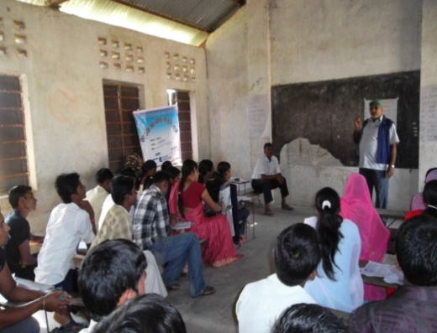
Unlike previous years, youths went to VDC office and demanded their participation in local decision making and access to local resource systematically. They communicated in non violent way and had dialogue in peacefully way. Youths from most of the working VDCs of Siraha and Saptari managed to receive budget from their respective VDCs and opportunity to participate in the meetings. The youths in many other working VDCs though could not receive such support from VDCs but had open, friendly dialogue with VDC regarding youth participation in decision making and access to VDC budget. VDCs are also ready to address the issues and concern of the youths. This has increased the possibility of collaboration with VDC in upcoming days.
Figure 3 VDC secretary and youths having interaction
The Women who never before recognized their rights to have access to local resource, participation in local decision making and importance of their role and contribution in community peacebuilding came to know about budget to women in the VDC and rights of participation in the local decision making. Women in small group visited VDC, had dialogue with the secrtaries and in majority VDCs women managed to have their entitled budget from the VDC. VDCs and women groups together conducted income generation trainings such as sewing and soap making.
Some impact of project
- Youth network in Mahottari have further been active particularly after receiving ToT. Being one ToT (Suresh Thakur, Bathnaha) the president of the network has been successful to work in collaboration with different origination such Human Rights Protection Centre, Women Awareness Group and Local Peace Committee etc. he could celebrate youth day and peace day in common banner and common participation with those organization.
- As the spillover effect of TPI Project, the youths of the adjacent VDCs: Bispiti VDC— neighboring VDC of Sasaula; Ankar VDC near Nanihi VDC and Barsapateli VDC—of Mahottari district have started creating pressure over the concerned secretary to allocate budget and provide space in decision making level for them.
- Youths have started taking participation in the VDC meeting. Suresh Thakur (Bathnaha), Sankar Yadav (Santipur), Ash Kr. Paswan (Debdia), Prakash Koirala (Badaharamal), Srawan Paswan (Kushaha) are attending VDC meeting.
- Youths have started working in collaboration with governmental and non governmental agencies in the district. Youth network in Dhanusha celebrated international peace day and youth day in collaboration with LPC and other governmental offices in Janakpur.
Shrawan Paswan–one of the participants of ToT and also the president of a CBO–Community Development Centre, of Kushaha of Saptari district– organized free Eye Camp in Kushaha Bazar in Bhadra 8 and in Sanhi VDC in Ashwin 8 of 2069 in collaboration with Sagarmatha Chaudhari Eye Hospital where more than 400 eye patients got their eyes checked and had free eye operation.
- After attending ToT, some women ToT participants are working in partnership of other organization. Manju Shreshtha of Bengadawar is leading infrastructure construction program in her community in coordination with RRN. Asni Lama and her group (Bishnupurkatti/Siraha) received one lakh from RRN for goat-keeping. Jayanti Chaudhari (Malhanma/Saptari) conducted sewing training together with VDC and provided sewing machine to women
- Awareness of youth and women on local resources, planning process and government policy has increased. Youths and women have eager to get involved in the development programs.
- Youth and Women (ToTs) have started leading community through development activities.
- Women leaders are contributing to empower and raise women awareness in their community after attending regional level training. Rakshy Chaudhari, Parwati Pande, Indu Paswan, Sugandha are few name to note, who are making contribution. They are facilitating in UN Res.1325 and women rights in VDC level leadership development training. Rakshya is organizing women leadership training in her own initiation in Saptari.
9. OUTPUTS OF THE PROJECT
- Training (ToT) on community peacebuilding, conflict analysis, local resource mobilization, leader and leadership, UN Res. 1325 & 1820 and NAP was held;
- Knowledge on peace, conflict, Violence, Leader and leadership, local resources and UN Res. 1325, 1820 and NAP increased.
- Skills on conflict mediation, peacebuilding, dialogue convene and facilitation, conflict analysis and income generating skills such as pickle–making, candle–making, incense stick–making and soap–making got transferred to local youths and women.
- LDM Training; local decision makers' knowledge on UN Res. 1325, 1820 and NAP along with Youth policy and community peace building was enhanced: 23 male and 3 female LDMs were trained
- RLWL: 23 regional level women leaders hailing from four districts and active in various social sectors were trained.
- VDC Level leadership development training - Training manual for VDC Level Leadership Development Training was prepared and used.
- Radio Testimony of 10 exemplary leaders was prepared and broadcasted
- 9 youths and women-led cooperatives were registered whereas one was further improved from the seed grant. 1254 youths and women along with 436 male and 818 female were directly benefitted from the seed grant activities. 187 youths and women along with 25 male and 162 female are involved in sustainable business plan. Two ‘Youth Dialogue and Information Centre’ have also been established in Dhanusha and Lahan.

Table 11: Output Table
S.N. | Activities | Frequency | Beneficiaries
1. | Training of Trainer (ToT) to youth | 1 | 24
2. | Training of Trainer (ToT) to Women | 1 | 24
3. | Youth Leadership Development Training | 20 | 589
4. | Women Leadership Development Training | 20 | 583
5. | Regional Level Women Leaders' Training | 1 | 23
6. | Local Decision Makers’ Training | 1 | 26
7. | Community Dialogue | 40 | 1070
8. | Community Orientation | 40 | 1212
9. | Seed Grant Activities | 20 | 1254
10. | Radio Testimony | 10 | 6 district
11. | Hamro Team Screening | 15 | 350
12. | FGD on Khula Dharti | Monthly | 6 districts
13. | Sangor Listenership session | Monthly | 150
14 | International Days Celebration | 4 | 1541
15 | Awards for VDC secretaries | 1 | 4
16 | District Advisory Committee Meeting | 8 | 40

Table 12: OUTPUT TABLE OF SUSTAINABILITY BUSINESS PLAN
S.N. | Activities | Frequency | Beneficiaries
1. | VDC Level Cooperative Management Orientation | 20 | 408
2. | Dialogue Facilitation Training | 1 | 14
3. | Cooperative Management Training | 1 | 27
4. | Seed Grant for Sustainable Business Plan | 10 | 187

10. LESSON LEARNT AND CHALLENGES
- Though there does not exist any political mechanism, political parties and their leaders still have dominant role in local decision making process. They act as de facto decision–makers in local body thereby reducing possibility of youths and women participation in decision making process. So political leaders are to be engaged through project activities particularly for changing their role from dominant to assistant to help run development activities in the VDC smoothly and guarantee good governance in them.
- Though, the project has increase a certain level of awareness among the women about their rights and local resources, majority of the women in rural areas are illiterate and no aware of legal provision on VAW and participation in decision-making hence are compelled to live within the four walls of the house. Patriarchic society; economic dependency on their men and lack of awareness on their rights; opportunity and government policy are limiting their potential role in community peacebuilding.
- VDC secretaries are frequently transferred from one VDC to another after certain time period so the support of VDC to the youths and women in the present working VDCs may not be continued if the incumbent secretaries get transferred to other VDCs as the new secretaries may not be as positive as the incumbent secretaries.
- Although, youths and women have initiated for sustainable projects like cooperatives for economic empowerment of youths and women to enable them to lead and contribute community peacebuilding, their initiatives for income generation and community peacebuilding are at the initial phase hence need still regular support and guidance. If they fail to receive technical guidance, their initiations are likely to come to a halt.
- Earning support and trust of political parties and its local leaders—who have been playing key roles since long in the community— is still a difficult task for the youths and women in community peacebuilding and development activities.
- Though, youths and women have started collaborative small entrepreneurship, it is yet to see how the youths and women collaboratively use their collective efforts to community peacebuilding and win the trust of the community.
- Youths and women activeness and initiation for conflict management in their respective communities proved that if knowledge and skills are transferred to youths and women or local communities, conflict management from the grassroots level is possible. This has also clearly showed that women and youths can also contribute to local peacebuilding.
- The impact of VDC secretary award in the district was encouraging but DDC and WDO were also seen the aspirant to such type of award. If made provision of the same type of award even to DDC and WDO, their role in empowering youths and women would be more positive and the result would be more encouraging.
- It is learnt that if knowledge, skill and support is given to youths and women, youths can be involved in creative activities. Women also come out of four walls and get involved in social activities. And such activities help youths and women get united for echoing voice for their rights.
- Peacebuilding is not possible in isolation in countries—like Nepal where there is high rate of poverty and unemployment—so it needs to link with livelihood of people. Peacebuilding activities need to have both—peace building and income generation objectives—then only peacebuilding becomes effective.
- Income generating activities need to be prepared on the ground reality—strength of the group and the VDC, future, interest of the group— rather than xerox of other successful entrepreneur groups otherwise income generating seed grant activities are difficult to implement.
11. BUDGET
Financial Report will be submitted in separate sheets.

ANNEXES
Annex 1 Proposed activities of the project
S.N. | Activities | Target |  | Frequency  to be held
 |  | Gender | Number
1. | Training of Trainer (ToT) to youth | Youth | 24 | 1
2. | Training of Trainer (ToT) to Women | Women | 24 | 1
3. | Youth Leadership Development Training | Youths in the VDCs | 400 | 20
4. | Women Leadership Development Training | Women in the VDCs | 400 | 20
5. | Regional Level Women Leaders' Training | Women working in the regional level | 24 | 1
6. | LDM Training | Local Decision Makers | 28 | 1
7. | Community Dialogue | Community people | Not specified | 40
8. | Community Orientation | Youths, women, LDMs, political leaders and others | Not specified | 40
9. | Seed Grant Activities | Youths, and women | 1000 | 20
10. | Radio Testimony | Community people | Radio listeners | 10
11. | Hamro Team Screening | Youths and students of schools and colleges | As many as possible | 15
12. | FGD on Khula Dharti | Youths | Not specified | Monthly
13. | Sangor Listenership session | Youths | Not specified | Monthly
14 | International Days Celebration | All the stakeholders | As many as possible | 4
15 | Awards for VDC secretaries | VDC secretaries | 4 secretaries | 1
16 | District Advisory Committee Meeting | Key stakeholders | 4 DPACs formation | 8

Annex 2.
Proposed Activities for Sustainability Business Plan

S.N. | Activities | Benefitted/involved/trained |  | Frequency/ events held | Geographical area covered
 |  | Gender | Number
1. | Community Orientation | Local Youth and women members | 400 | 20 | Siraha, Saptari, Dhanusha and Mahottari
2. | Cooperative Management | President/Treasurer/ member | 25 | 1 | Siraha, Saptari, Dhanusha and Mahottari
3. | Dialogue Facilitation | Members of Youth Information and Dialogue centre | 12 | 1 | Siraha, Saptari, Dhanusha and Mahottari
4. | VDC Secretary award ceremony Management | VDC Secretaries | 4 secretaries awarded | 1 | Siraha, Saptari, Dhanusha and Mahottari
5. | Seed grant | Youth and Women Group | Not specified | 10 | Siraha, Saptari, Dhanusha and Mahottari

Annex 3 Activities Carried Out and Beneficiaries
S.N. | Activities | Frequency/event held | Involved/benefitted/trained |  | Geographical area covered
 |  |  | Gender | Number
1. | Training of Trainer (ToT) to youth | 1 | Youth | 24 | Siraha, Saptari, Dhanusha & Mahottari
2. | Training of Trainer (ToT) to Women | 1 | Women | 24 | Siraha, Saptari, Dhanusha & Mahottari
3. | Youth Leadership Development Training | 20 | Youths in the VDCs | 589 | 20 VDCs from four districts (5 VDCs from each district)
4. | Women Leadership Development Training | 20 | Women in the VDCs | 583 | 20 VDCs from four districts (5 VDCs from each district)
5. | Regional Level Women Leaders’ (RLWL) Training | 1 | Women working in the regional level | 24 | Siraha, Saptari, Dhanusha & Mahottari
6. | Local Decision Makers’ (LDMs) Training | 1 | Local Decision Makers | 28 | Siraha, Saptari, Dhanusha & Mahottari
7. | Community Dialogue | 40 | Community people | 1070 | 20 VDCs from four districts (5 VDCs from each district)
8. | Community Orientation | 40 | Youths, women, LDMs, political leaders and others | 1212 | 20 VDCs from four districts (5 VDCs from each district)
9. | Seed Grant Activities | 20 | Youths and women | 1254 | 20 VDCs from four districts (5 VDCs from each district)
10. | Radio Testimony | 10 | Community people | Listeners of 6 districts | Siraha, Saptari, Dhanusha and Mahottari
11. | Hamro Team (HT) Screening | 4 times screening session convened | Youths and students of schools and colleges | 361 | Siraha, Saptari, Dhanusha and Mahottari
12. | FGD on Khula Dharti | 7 times held | Youths | Not specified | Siraha, Saptari, Dhanusha and Mahottari
13. | Sangor Listenership session | 7 times held | Youths | Not specified | Siraha, Saptari, Dhanusha and Mahottari
14 | International Days Celebration | 4 times marked | All the stakeholders | 1541 | Siraha, Saptari, Dhanusha and Mahottari
15 | Awards for VDC secretaries | 1 time convened | VDC secretaries | 4 secretaries awarded | Siraha, Saptari, Dhanusha and Mahottari
16 | District Advisory Committee Meeting | 8 times meeting held | Key stakeholders of the districts | 4 DPAC formed | Siraha, Saptari, Dhanusha and Mahottari

Annex 4. Beneficiaries of Seed Grant Activities
District/  VDC | Types of Seed Grant Activities | Implementing Youth Club/ Women Group | Beneficiary of Seed grant Activities
 |  |  | Male | Female
 |  | SAPTARI DISTRICT
Kushaha | Agricultural Cooperative (Youth & Women: Joint) | Community Dev. Service Centre and Community Women Dev. Committee | 9 | 21
Bakhdhuwa | Saving and Loan Cooperative Mgt. | Women Awareness Society | 0 | 25
 | Poultry Farming | Community Service Forum (Youth) | 11 | 12
Mohanpur | Credit and Loan Cooperative | Women Empowerment Group | 0 | 29
 | Peace Journalism and Anchoring Training | Lucky Adolescent and Youth Union Club | 13 | 11
Malhanma | Youth club registration (youth) | Youth Unity Forum | 12 | 19
 | Credit and Loan Cooperative | Aware Women Group | 0 | 32
Haripur | Soap-Making Training (Joint) | Untouchable People Welfare and Protect Centre and Women group; Sunflower Women Saving and Credit Cooperative ltd | 0 | 35
 |  | SIRAHA
Bhadaiya | Credit and Loan Cooperatives (Joint) | Laligurans Women Group and Sunaulo Bihani Youth Club | 14 | 17
Bishnupurkatti | Cooperative management and collaborative leadership, decision making and consensus making training (women) | Sungabha Women Saving and Loan Cooperative Ltd. | 0 | 35
 | Agro based cooperative (youth) | Jana Prayas Youth Club | 25 | 14
Badaharamal | Youth Initiation against Drugs addiction (youth) | CEEP Nepal, Bandipur | 16 | 7
 | Chair Making Training | Jagriti Women Group | 0 | 35
Arnama Pra. Pi. | Soap and surf making training(Joint) | Women Dev. Group and Youth Unity Club (Joint) | 13 | 28
Sonmatimajhaura | Youths Club registration (not yet financially supported) | Janakalyan Youth Club | 20 | 11
 | Micro Saving and Group Mobilization Training | Shrijanshil Mahila Samuha | 3 | 27
District/  VDC | Types of Seed Grant Activities | Implementing Youth Club/ Women Group | Beneficiary of Seed grant Activities
 |  |  | Male |  | Female
 |  | DHANUSHA
Bengadawar | Sewing Training | Creative Women Group | 0 |  | 11
 | Computer Training | Mithila Youth Club | 10 |  | 0
Godar | Paper-making Training | Community Development Forum | 0 |  | 15
 | Pickle-making Trainign | Ma Durga Women Group | 0 |  | 15
Santipur | Agriculture Cooperative (Joint) | Nadurga Youth Club and Janki Women Group | 10 |  | 20
Ramdaiya | Cricket Game | Laligurans Charpate Youth Club | 132 |  | 0
 | Health Camp | Sri Saraswoti Women Group and Laligurans Charpate Youth Club | 0 |  | 200
Debdia | Soap-making training (Joint) | Sahlesh Youth Club and Sahlesh Women Group | 0 |  | 35
 | MAHOTTARI
Suga | Candle-Making Training | Shree Krishna Youth Club | 3 |  | 24
 | Agriculture Cooperatives | Women Capacity Development Peace Group | 0 |  | 27
Bathnaha | Agriculture Cooperatives (Joint) | Hanuman Youth Club & Women Peace Group | 8 |  | 37
Sasaula | Incense-Stick Making Training | Women Changeable Peace Group | 0 |  | 21
 | Cricket Game | Mithila Youth Club | 90 |  | 0
Banauta | Agriculture Cooperative | Asal Nagarik Youth club | 24 |  | 28
 | Candle-making Training | Women Empowerment Peace group | 0 |  | 20
Nainhi | Incense-Stick Making Training | Women Welfare Peace group | 0 |  | 30
 | Youth Leadership Training and Quiz contest | Nainhi Service Committee | 8 |  | 10
Total | Number of youth clubs and women groups: 40 | Activities held: 33 | 436 |  | 818
 |  |  | 1254

Annex 5.

Table 3: Participants of VDC Level Youth Leadership Development Training

District | VDC | Held Date | Participants
 |  |  | Male | Female | Total
Saptari | Kushaha | Sept 27-28, 2012 | 14 | 11 | 25
 | Haripur | Oct 12-13, 2012 | 17 | 11 | 28
 | Malhanma | Dec 28 & 29, 2012 | 16 | 12 | 28
 | Mohanpur | November 2-3, 2012 | 16 | 12 | 28
 | Bakdhuwa | Nov16-17, 2012 | 18 | 11 | 29
Siraha | Sonamati Majhaura | October 12-13, 2012 | 23 | 7 | 30
 | Bhadaiya | Sept 29-30, 2012 | 16 | 21 | 37
 | Bishnupur Katti | October 19-20, 2012 | 25 | 15 | 40
 | Arnama Pra. Pi. | Nov 28-29, 2012 | 18 | 9 | 27
 | Badaharamal | Dec 21-22, 2012 | 19 | 8 | 27
Dhanusha | Bengadawar | Dec 2 &3, 2012 | 21 | 7 | 28
 | Debdiha | Dec 5& 6, 2012 | 24 | 5 | 29
 | Godar | March 6 & 7, 2012 | 18 | 10 | 28
 | Ramdaiya | Dec 24 – 25, 2012 | 28 | 7 | 35
 | Shantipur | Dec 7 & 8, 2012 | 17 | 6 | 23
Mahottari | Sahasaula | October 28-29, 2012 | 20 | 10 | 30
 | Nainhi | Oct31- Nov. 1 2012 | 21 | 13 | 34
 | Bathanaha | October 14-15, 2012 | 23 | 9 | 32
 | Banauta | Dec 18-19, 2012 | 12 | 8 | 20
 | Suga | Sep 22-23, 2012 | 10 | 21 | 31
Total Participants |  |  | 376 | 213 | 589

Annex 5.

Table 3: Participants of VDC Level Women Leadership Development Training

District | VDC | Held Date | Participants
Saptari | Kushaha | December 2-3, 2012 | 27
 | Haripur | December 24 -25, 2012 | 27
 | Malhanma | December 22-23, 2012 | 27
 | Mohanpur | November 2-3, 2012 | 27
 | Bakdhuwa | December 4-5, 2012 | 25
Siraha | Sonamati Majhaura | December 18-19, 2012 | 30
 | Bhadaiya | December 15-16, 2012 | 33
 | Bishnupur Katti | November 6-7, 2012 | 27
 | Arnama Pra. Pi. | November 26-27, 2012 | 27
 | Badaharamal | December 21-22, 2012 | 36
Dhanusha | Bengadawar | September 25-26, 2012 | 42
 | Debdiha | December 2-3, 2012 | 33
 | Godar | January 4-5, 2013, 2012 | 21
 | Ramdaiya | December 26-27, 2012 | 26
 | Shantipur | December 12-13, 2012 | 32
Mahottari | Sahasaula | December 21-22, 2012 | 33
 | Nainhi | December 23-24, 2012 | 28
 | Bathanaha | October 14-15, 2012 | 31
 | Banauta | December 28-29, 2012 | 23
 | Suga | November 5-6, 2012 | 28
 |  | Total Participants | 583

Annex 6

Caste-wise, Sex-wise Distribution of the Participants in the Activities of the project

Women Leadership Development Training

Annex 7. Partner Youth Clubs Distribution
DISTRICT | YOUTH
 | VDC | Youth Club | Formation date | Board Member | Legal Status | Contact Person
SIRAHA | Bishnupur Katti | Jana Prayash Community Dev. Centre | 2058 -02-16 | Total: 11 Male : 7  Female: 4 | Registered 2058 -02-16 | Jageshwor Yadav  Mob:9842911447
 | Barharama (Bandipur) | Seep Nepal | 2066 -5-8 | T: 15 M: 9  F: 5 | Registered 2066-9-2 | Parkash Koirala Mob: 9807768533
 | Arnma pra. pi. | youwa yakta klab | 2053-5-15 | T: 11 M: 9  F: 2 | Registered 2053-9-22 | Poshan Yadav Mob; 9842835150
 | Sonmati Majhaura | Jankalyan youba Club | 2069-2-20 | T: 21 M: 18  F: 3 | Not | Arun chy. Mob: 9815752474
 | Bhadaiya | Sunaulo Bihani Youba Club | 2069-2-25 | T: 15 M: 11  F:4 | Not | Barmadeb Chaudhari
SAPTARI | Kusaha | Samudayik Vikas Kendra | 2065 | T: 11 M: 4  F: 7 | Registered  2065 | Shrawan yadav  Mob:9816734707
 | Haripur | Dalit Utthan sanrkshan Kendra | 2064 | T: 11 M: 4  F: 7 | Registered  2064/2065 | Pramod Kumar ram  Mob:9807733138
 | Malahanma | Yuba Ekata Club | 2069 | T: 7 | Not Registered | Birendra paswan  M. : 9805911420
 | Mohanpur | Bhagyashali kishor kishiri yuwa sangam | 2051 | T: 11 M: 6  F: 5 | Registered  2057 | Chandra narayan chaudhary
 | Bakadhuwa | Samudayik sewa Manch | 2055 | T: 7 M: 5  F: 2 | Registered  2057 | Sudarshan Chaudhary  M.9841060089
MAHOTTARI | Bathanaha | Hanuman Youth Club | 2065/2/14 | T:9 M:7  F:2 | 2066 | Suresh Thakur  Mob:9804845228
 | Banauta | Ashal Nagrik Yuwa Club | 2061 | T:9 M:7  F:2 | 2065 | Bal Ram Yadav  Mob;9814858383
 | Sahsaula | Shree Mithila Youth Club | 2063/4/10 | T:11 M:7  F:4 | 2063/8/20 | Ram Naresh Chaudhary  Mo, 9744002157
 | Suga | Krishan Youth Club | 2065/1/24 | T:11 M:6  F:5 | 2065/12/25 | Nagendra Paswan  Mo,9804848137
 | Nainhi | Shree Nainhi Yuwa Sewa Samiti | 2066/02/15 | T:11 M: 8  F:3 | 2066/07/15 | Nabin kumar Mishara  Mo,9807890990
DHANUSHA | Bengadawar | Shree Mithila Youth Club | 2058 | T:11 M:9  F:2 | Registered  2058 | Shreekisun Mahato  9815833427
 | Shantipur | Shree Nabdurga Youth Club |  | T: M:  F: |  | Shankar Yadav  9804881182
 | Ramdaiya | Shree Laliguransh Chaarpate Youth Club | 2032 | T: 25 M: 22  F: 3 | Registered in 2059 | Tulsiram Yadav  9807824951
 | Godar | Shree Samaj Sewa Youth Club | 2062 | T: M:  F: | Registered  2062 | Ranjit Mahato
 | Debdiha | Shree Shalhesh Youth Club | 2062 | T:9 M:9  F:no | Registered  2062 | Aash kumar Paswan

Annex 8. Partner Women Groups Distribution

DISTRICT | WOMEN
 | VDC | Women Group | Formation Date | Board Member | Legal Status | Contact person
SIRAHA | Bishnupur Katti | Sungabha Women Savings & Cooperative | 2062 -01-27 | T: 9 M:  f: 9 | Registered  (2069-2-10)  Baishak) | Asmi Lama  Mob: 9808690600
 | Barharama (Bandipur) | Jagriti Mahila Samuha | 2069-1-9 | T: 15 M:  F: 15 | Not Registered | Uma Debi pande Mob:9814791791
 | Arnma pra. pi. | Mahila Bikash Samuh | 2068-6-25 | T: 9 M:  F: 9 | Not Registered | Urmila sing
 | Sonmati Majhaura | Srijanshil Women Group | Not formed | F:30 | Not Registered | Samjhana BK
 | Bhadaiya | Laligurans Women Group | Not Formed | F: 27 | Not Registered | Khemkumari Sinha
SAPTARI | Kusaha | Community woman development committee | 2068/04/02 BS | 9 | Registered  (2068/04/o2 | Satyabati chaudhary  Samjhana chaudhary  Mob: 9814725949
 | Haripur | Dip jyoti mahila samuh | 2060 | 13 | Registered  (2061 | Phulkumari Ram  Mob: 9807762431
 | Malahanma | Mahila jagriti Samuh | 2065 | 11 | Non Registered | Ratan devi chaudhary  M.9814785572
 | Mohanpur | Mahila sashaktikaran karykram | 2067 | 11 | Non Registered | Sabitri devi Mandal  M.9817705268
 | Bakadhuwa | Mahila Jagarn Samag, Mahuli | 2055 | 11 | Registered  2056 | Kusum aachary  M. 9817774621
MAHOTTARI | Bathanaha | Mahila Utthan Samuh | 2067/68 BS | 11 | Not registered | Sangita Thakur  Mob:
 | Banauta | Mahila Sashaktikaran Santi Samuha | 2069 | 11 | Not registered
 | Sahsaula | Mahila Sashaktikaran Samuha | 2069 | 15 | Not registered | Sarita Jha
 | Suga | Woman Empower Development Peace Groups | 2067 /BS | 11 | Not registered | Sunaina Thakur  9819812174
 | Nainhi | Mahila Utthan Samuha | 2069 | 15 | Not registered
DHANUSHA | Bengadawar | Shrijana Nagarik Sachetana Kendra | 2068/11/10  Ward 3 | 7executive member  26General member | Not registered | Manju Shrestha  9807818988
 | Shantipur | Janki Women Group  (Newly Formed Group) | 2069 |  | Not Registered | Charimaya Bhujel
 | Ramdaiya | Sri Saraswoti Women Group | 2069 |  | Not Registered | Babita Yadav
 | Godar | Jay Ma Durga Saving and Cooperative | 2066/8/5 | 13 executive members  400general members | registered | Rita Devi Yadav  9841242461
 | Debdiha | Shree Shalhesh Mahila Samuh | 2069 | 11 | Not registered | Chanda Paswan  9807812350

Annex 9
Newly Registered Cooperatives limited in Support of TPI Project
S.N. | VDC | Name/Type of Cooperative | Members of Cooperative |  |  | Initial Share (In figure) | Registration | Remarks
 |  |  | Male | Female | Total
SAPTARI DISTRICT
1 | Kushaha VDC | Agriculture | 9 | 21 | 30 | 75,000 | Registered | New
2 | Malhanma VDC | Agriculture | 0 | 22 | 22 | 75,000 | Registered | (New
3 | Bakdhuwa VDC | Saving & Credit | 0 | 25 | 25 | 5,000 | Registered | Old
SIRAHA DISTRICT
4 | Bhadaiya | Amritpan Agriculture Cooperatives | 13 | 14 | 27 | 83,000 | Registered | New
5 | Bishnupur | Saving & Credit | 0 | 30+ | 41 | 3,00,000 | Registered this year | Old
6 |  | Agriculture |  |  |  |  | On process | New
DHANUSHA DISTRICT
7 | Santipur | Agriculture | 10 | 20 | 30 | 75,000 | On process | New
8 | Debdiha | Agriculture | 5 | 25 | 30 | 38,000 | Registered | New
MAHOTTARI DISTRICT
9 | Suga | Agriculture | 3 | 24 | 27 | 25,000 | Registered | New
10 | Bathnaha | Agriculture | 8 | 37 | 45 | 1,00,000 | Registered | New
11 | Banauta | Agriculture | 5 | 20 | 25 | 65,000 | Registered | New

Annex 10
Activities Carried Out and Beneficiaries of Sustainability Business Plan

District/  VDC | Types of Seed Grant Activities | Implementing Youth Club/ Women Group | Beneficiary of Seed grant Activities
 |  |  | Male | Female
 |  | SAPTARI DISTRICT
Kushaha | Agricultural Cooperative and Goat keeping | Community Dev. Service Centre and Community Women Dev. Committee | 4 | 16
Bakhdhuwa | Saving and Loan Cooperative Mgt. and Micro Business | Women Awareness Society | 0 | 10
Mohanpur | Credit & Saving Cooperative and Vegetable farming | Women Empowerment Group | 0 | 11
Malhanma | Credit & Saving Cooperative and Vegetable farming, fish farming | Aware Women Group | 0 | 9
Haripur | Soap-Making Training (Joint) | Untouchable People Welfare and Protect Centre and Women group; Sunflower Women Saving and Credit Cooperative ltd | Not Implemented
 |  | SIRAHA
Bhadaiya | Credit & Saving Cooperatives (Joint) and Collective Vegetable Farming | Laligurans Women Group and Sunaulo Bihani Youth Club | 13 | 14
Bishnupurkatti | Goat Keeping | Sungabha Women Saving and Loan Cooperative Ltd. | 0 | 10
Badaharamal | Goat Keeping and  Chair Making Training | CEEP Nepal, Bandipur and  Jagriti Women Group | 0 | 10
Arnama Pra. Pi. | Soap and surf making training(Joint) | Women Dev. Group and Youth Unity Club (Joint) | 0 | 23
District/  VDC | Types of Seed Grant Activities | Implementing Youth Club/ Women Group | Beneficiary of Seed grant Activities
 |  |  | Male |  | Female
 |  | DHANUSHA
Bengadawar | Building Construction | Creative Women Group and  Mithila Youth Club | Seed grant distribution on process
Godar | Paper-making Training | Community Development Forum | Seed grant distribution on process
 | Pickle-making Training | Ma Durga Women Group
Santipur | Agriculture Cooperative and Vegetable farming | Nadurga Youth Club and Janki Women Group | 4 |  | 3
Debdia | Agriculture Cooperative and Vegetable farming | Sahlesh Youth Club and Sahlesh Women Group | 0 |  | 10
 | MAHOTTARI
Suga | Candle-Making Training | Shree Krishna Youth Club | 0 |  | 10
 | Agriculture Cooperatives and Mithila Painitng | Women Capacity Development Peace Group | 0 |  | 5
Bathnaha | Agriculture Cooperatives and incense-making | Hanuman Youth Club & Women Peace Group | 0 |  | 10
Sasaula | Incense-Stick Making Training | Women Changeable Peace Group | Not Implemented
 | Cooperative | Mithila Youth Club
Banauta | Agriculture Cooperative and Candle-making | Asal Nagarik Youth club  Women Empowerment Peace group | 4 |  | 6
Nainhi | Incense-Stick Making Training | Women Welfare Peace group | 0 |  | 15
Total | Number of youth clubs and women groups: | Activities held: | 25 |  | 162
 |  |  | 187

Annex 11
Participants of Cooperative Orientation
District | VDC | DATE | PARTICIPANTS
 |  |  | Male | Female | Total
Saptari | Bakhdhuwa | July 6 | 0 | 24 | 24
 | Mohanpur | July 8 | 0 | 18 | 18
 | Kushaha | July 13 | 8 | 14 | 22
 | Haripur | July 30 | 3 | 24 | 27
 | Malhanma | July 31 | 0 | 20 | 20
Siraha | Arnama Pra. Pi. | July 7 | 2 | 28 | 30
 | Bishnupur | July 5 | 0 | 31 | 31
 | Sonmatimajhaura | July 4 | 4 | 28 | 32
 | Bhadaiya | July 8 | 4 | 12 | 16
 | Badaharamal | July 14 | 2 | 16 | 18
Dhanusha | Bengadawar | July 8 | 4 | 12 | 16
 | Debdiha | July 25 | 11 | 9 | 23
 | Santipur | July 23 | 11 | 12 | 23
Mahottari | Banauta | June 29 | 19 | 5 | 24
 | Sasaula | July 3 | 10 | 11 | 21
 | Nainhi | July 1 | 10 | 10 | 20
 | Bathnaha | July 14 | 5 | 20 | 25
 | Suga | July 15 | 18 | 17 | 18
Total |  |  | 111 | 297 | 408

Annex 12
VDC Secretaries’ Final Evaluation Score

District | VDCs | Evaluation by Youth club & Women Group  (60%) | Evaluation by DDC  (30%) | Peer Group Evaluation  (10%) | Total Marks obtained  (100%)
Saptari | Kushaha | 43 | 18 | 8.1 | 69.1
 | Malhanma | 40 | 18 | 8.9 | 66.9
 | Haripur | 28 | 15 | 7.9 | 50.4
 | Mohanpur | 52 | 25 | 9.5 | 86.5
 | Bakhdhuwa | 46 | 18 | 9.8 | 73.8
Siraha | Bhadaiya | 16 | 28 | 7.2 | 51.2
 | Bishnupurkatti | 48 | 28 | 8.2 | 84.2
 | Badaharamal | 42 | 29 | 8.4 | 79.4
 | Sonmatimajhaura | 20 | 27 | 7.7 | 54.7
 | Arnama Pra.Pi. | 18.5 | 26 | 7.6 | 52.1
Dhanusha | Godar | 29 | 23.4 | 0 | 52.4
 | Bengadawar | 52 | 24.3 | 0 | 76.3
 | Santipur | 14 | 24 | 0 | 38
 | Ramdaiya | 17 | 22.5 | 0 | 39.5
 | Debdiha | 20 | 24 | 0 | 44
Mahottari | Suga | 7 | 9.9 | 6.3 | 23.2
 | Sasaula | 10 | 19.5 | 4.5 | 34
 | Nainhi | 14 | 0 | 4 | 18
 | Bathnaha | 45 | 9.9 | 8.3 | 63.2
 | Banauta | 14 | o | 7.5 | 21.5

Annex 13. PROJECT IN PICTURES
Figure 4 Joint Secretary of MoPR during the LDM Training
Figure 5Youths marking international youth day
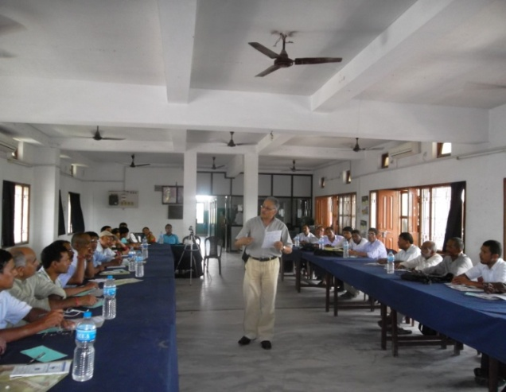
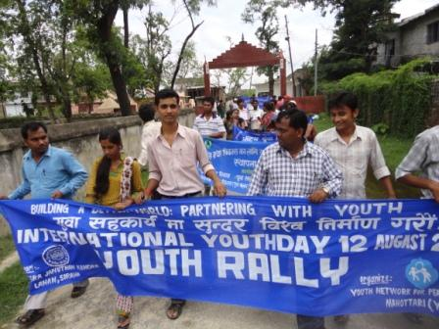

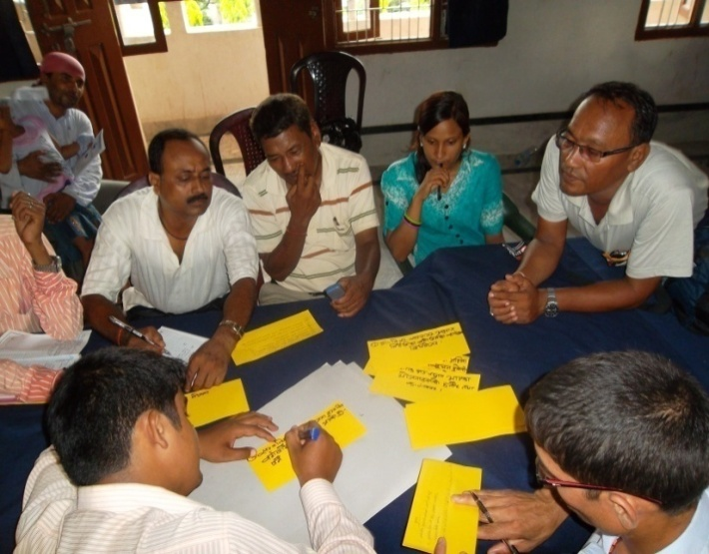
Figure 6 LDMs together with youths developing score card

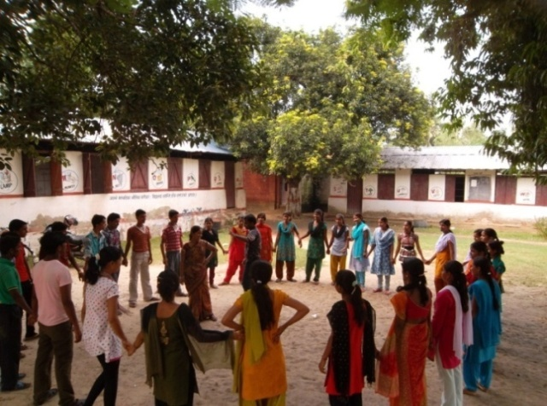
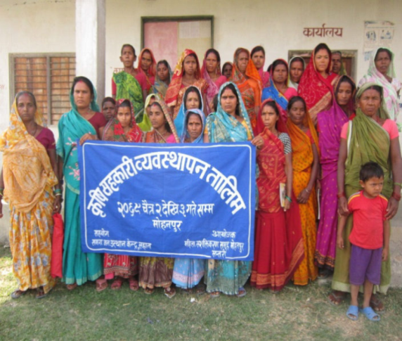
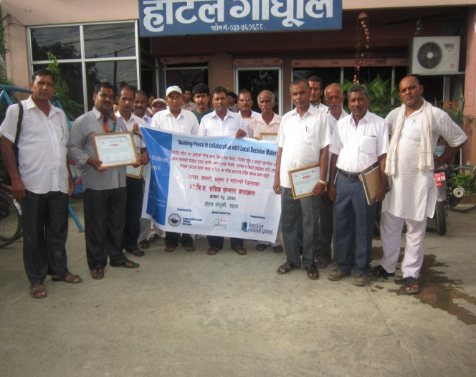
Figure 7 Youths during the leadership development training

Figure 9 VDC secretaries after felicitation program
Figure 8 women participants of cooeprative management training
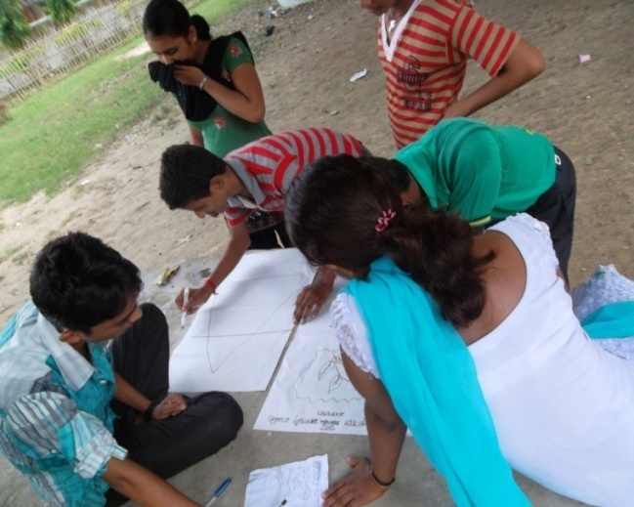
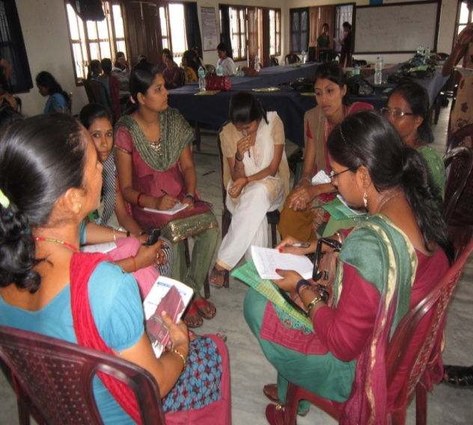
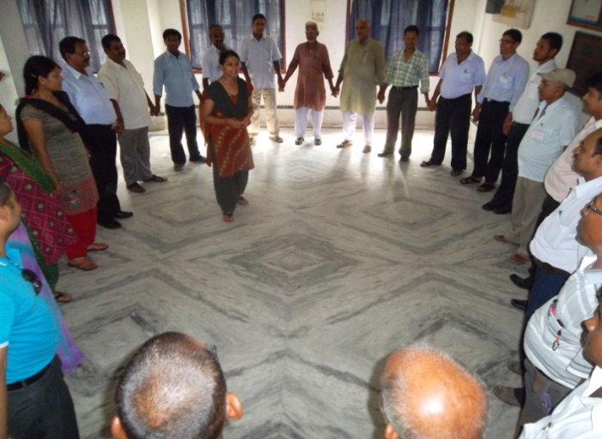
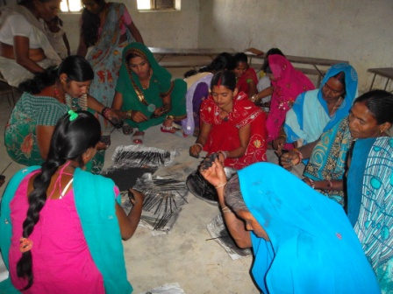
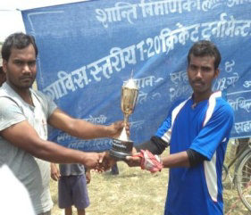
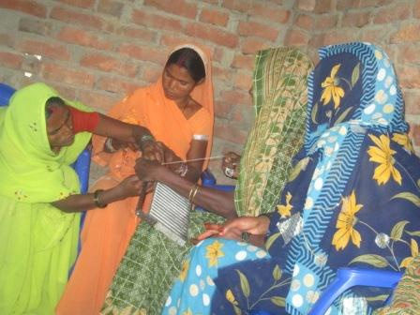
Figure 10 Youths analysing conflict
Figure 11 RLWL practising dialogue facilitation
Figure 12 LDMs during the training
Figure 13Women making incense-stick
Figure 14 Youth receiving tropy after cricket game
Figure 15 Women from Suga making candle

Baseline Survey 2011, SFCG

